Issue: Screener-05
Login User: screener1
Screener type users are responsible for screen application only.
Steps/Process to reach to the issues | Input/Data | Errors/Bugs | Expectations
Product Registration Form->Screening tab. When clicked on “Archive” button | Mouse click only | Unexpected error occurred after click on “Archive” button in screen tab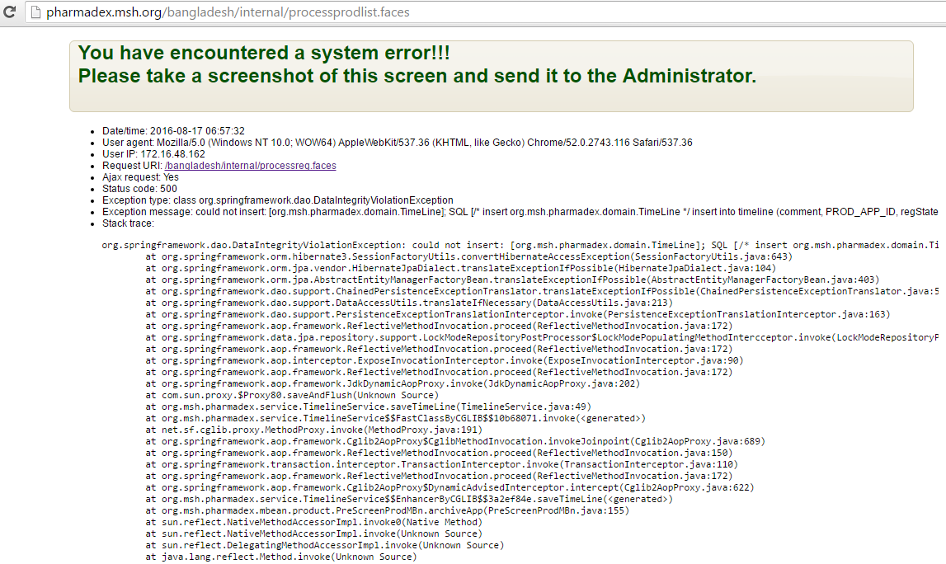 | Need to fix the error

