Issue: Screener-04
Login User: screener1
Screener type users are responsible for screen application only.
Steps/Process to reach to the issues | Input/Data | Errors/Bugs | Expectations
Product Registration Form->Sample request letter | Automatically generated this letter during sample request (As above input) | Product application specific request information is missing in this letter. No reflection found based on input.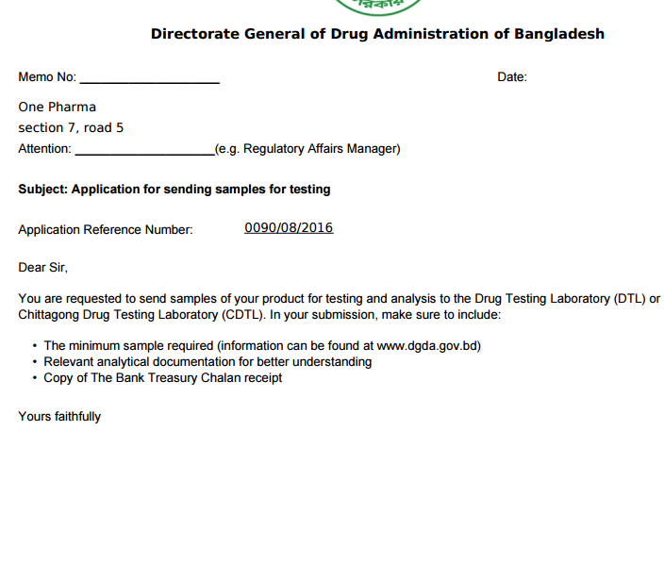 | Need to include all associated information. Need to align, line space and margin also.

