Issue: Screener-03
Login User: screener1
Screener type users are responsible for screen application only.
Steps/Process to reach to the issues | Input/Data | Errors/Bugs | Expectations
Product Registration Form->Sample request tab | Mouse click and input data as per screenshot | After screening completed by screener user, he/she able to send sample request as well as receive sample notification which are not standard. After screening everything will be locked.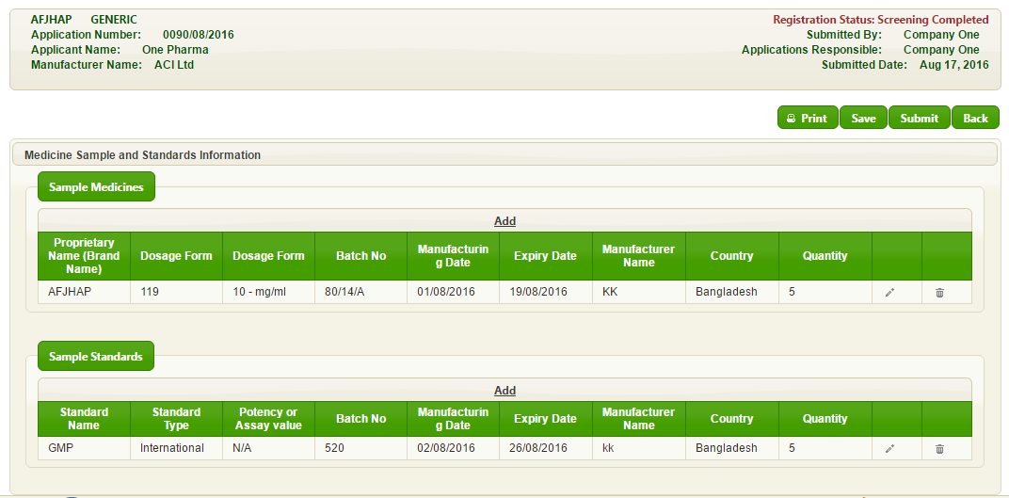 | Need to edit lock after screening. Only follow-up status of the application is editable by screener.

