Issue: Moderator-3
Login User: moderator1
Moderator type user is only responsible for coordinate among reviewer, screener and head with giving evaluation summary and recommendation.
Steps/Process to reach to the issues | Input/Data | Errors/Bugs | Expectations
Registration->Application Processing->Process Product Application->select product (AFJHAP)->Assessment tab->click on “Reviewer One”   to view review’s response and comments. Then click on “Deficiency Report” tab and click on generate button | Mouse click on General letter and the click on submit after input “due date” as 19/08/2016 and “Evaluation summary” as “Go ahead” only. | No input represented/reflected as required to generate reviewer level deficiency letter.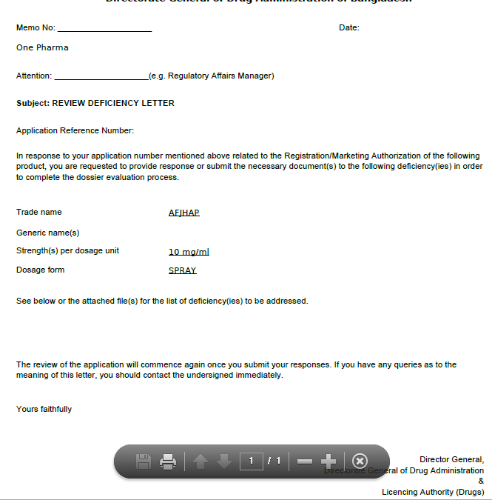 | Memo No, Date, Attention and deficiencies as per evaluation summary.

