Issue: Moderator-1
Login User: moderator1
Moderator type user is only responsible for coordinate among reviewer, screener and head with giving evaluation summary and recommendation.
Steps/Process to reach to the issues | Input/Data | Errors/Bugs | Expectations
Registration->Application Processing->Process Product Application->select product (AFJHAP)->Sample Request | Mouse click/No data | If multiple same received from applicant then RED mark is invalid. So, need to re-think based on different sample. 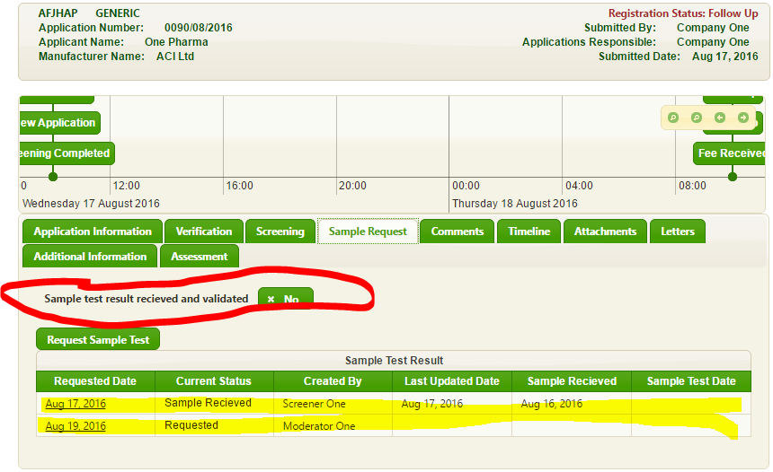 | It should be in right/left side of “Sample Test Result” section individually.

