Issue: Applicant-01
Login User: Company1
Applicant type user’s are responsible for sending online application and CTD-based dossier in a CD/DVD media and/or hard copy
Steps/Process to reach to the issues | Input/Data | Errors/Bugs | Expectations
Product Registration Form->Letters tab after click on rejection (Applicant self-generated by company1 as above issue) | Mouse click (No data) | Found Acceptance letter instead of rejection letter.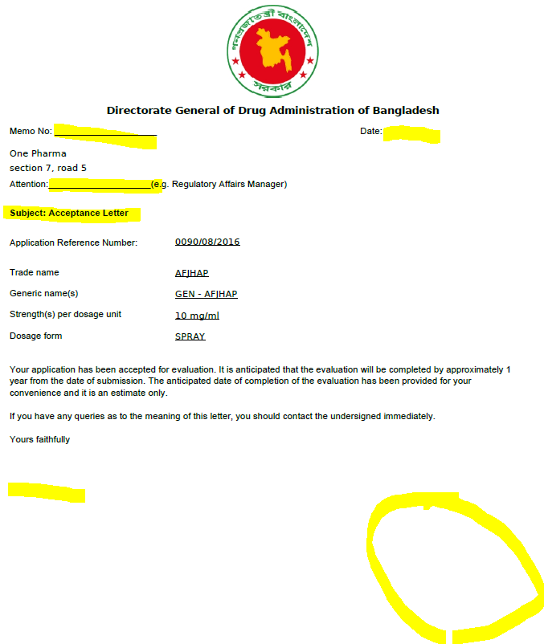 | Need to incorporate rejection letters

