Issue: Applicant-03
Login User: Company1
Applicant type user’s are responsible for sending online application and CTD-based dossier in a CD/DVD media and/or hard copy
Steps/Process to reach to the issues | Input/Data | Errors/Bugs | Expectations
Product Registration Form->Price Information tab | Mouse Click on next button | Price information need to be redesigned as per our earlier requirement (See the change request spreadsheet). Pack size wise price information.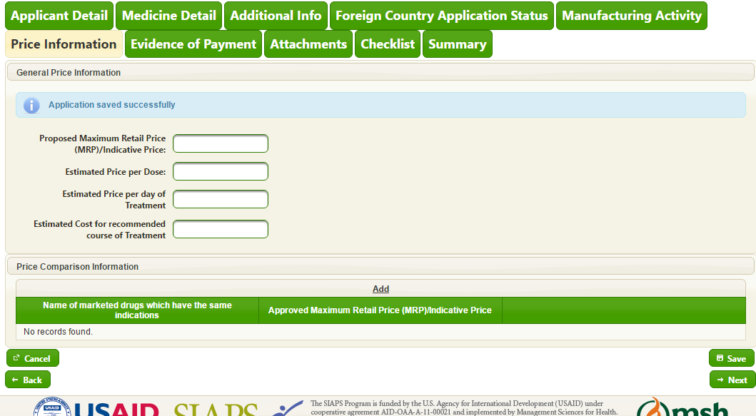 | Pack size wise price information. Add field in top of the field group/set as pack size.

