Issue: Admin-03
Login User Name: Admin
Admin user type is responsible for managing users and applicant’s registration as per submitted documents.
Steps/Process to reach to the issues | Input/Data | Errors/Bugs | Expectations
Registration->Post Registration Processing->Expiring Registration | Mouse click (No data input) | 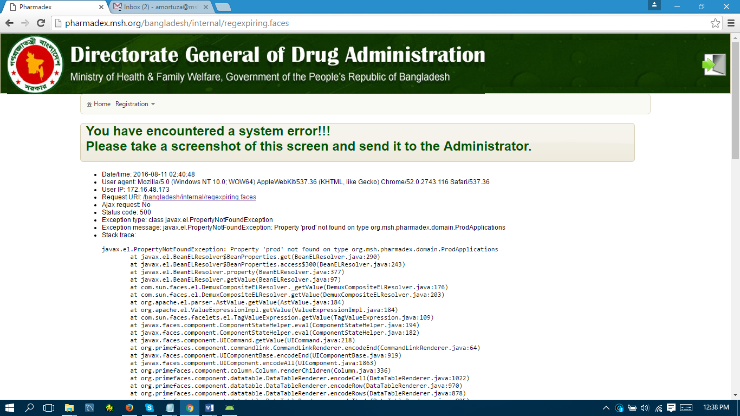 | Need to fix the error

