An additional warning message was added

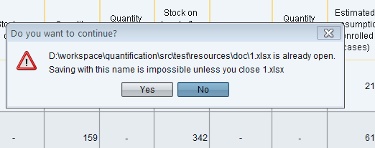

While this message is on screen, user has a possibility to close 1.xlsx

