Copy data from Excel to the QuanTB enrolled cases data

# Source data

Suppose, exists Excel table with enrolled cases data. For example:

|  |  |  |  |  |  |  |  |  |
| --- | --- | --- | --- | --- | --- | --- | --- | --- |
|  | Mar-13 | Apr-13 | May-13 | Jun-13 | Jul-13 | Aug-13 | Sep-13 | Oct-13 |
| 2(RHZE)/4(RH) - (weight 40-54kg) | 1 | 2 | 3 | 4 | 5 | 51 | 52 | 53 |
| Adult First Line New 2(RHZE)/6(EH) | 6 | 7 | 8 | 9 | 10 | 11 | 12 | 13 |
| First Line - Retreatment cases 2S(RHZE)/1RHZE/5(RHE) | 14 | 15 | 16 | 17 | 18 | 19 | 20 | 21 |
| Paediatric cases-15-19kg 2(RHZ)/4(RH) | 22 | 23 | 24 | 25 | 26 | 27 | 28 | 29 |

This data can be easy copied to the QuanTB enrolled cases data.

# Copy process

Select only cases quantity data, and copy

|  |  |  |  |  |  |  |  |  |
| --- | --- | --- | --- | --- | --- | --- | --- | --- |
|  | Mar-13 | Apr-13 | May-13 | Jun-13 | Jul-13 | Aug-13 | Sep-13 | Oct-13 |
| 2(RHZE)/4(RH) - (weight 40-54kg) | 1 | 2 | 3 | 4 | 5 | 51 | 52 | 53 |
| Adult First Line New 2(RHZE)/6(EH) | 6 | 7 | 8 | 9 | 10 | 11 | 12 | 13 |
| First Line - Retreatment cases 2S(RHZE)/1RHZE/5(RHE) | 14 | 15 | 16 | 17 | 18 | 19 | 20 | 21 |
| Paediatric cases-15-19kg 2(RHZ)/4(RH) | 22 | 23 | 24 | 25 | 26 | 27 | 28 | 29 |
|  |  |  |  |  |  |  |  |  |

Open the QuanTB forecasting document and set page “Parameters”

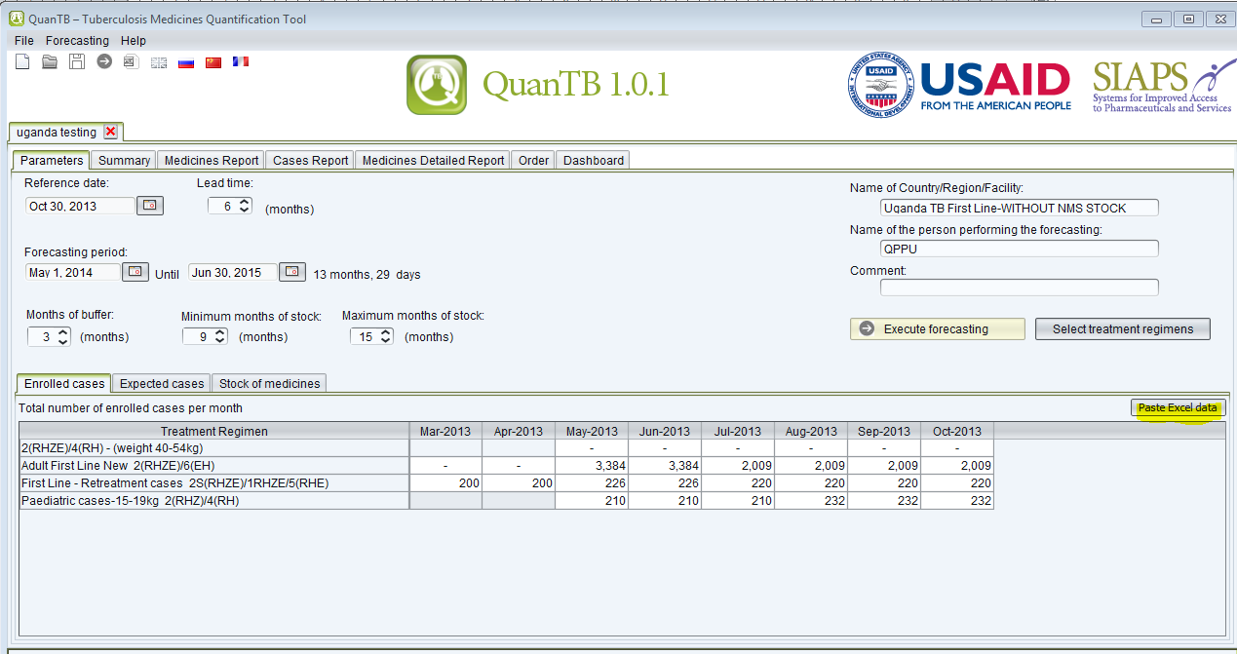

Press the button “Paste Excel data”

Cases quantities will be same as in the Excel

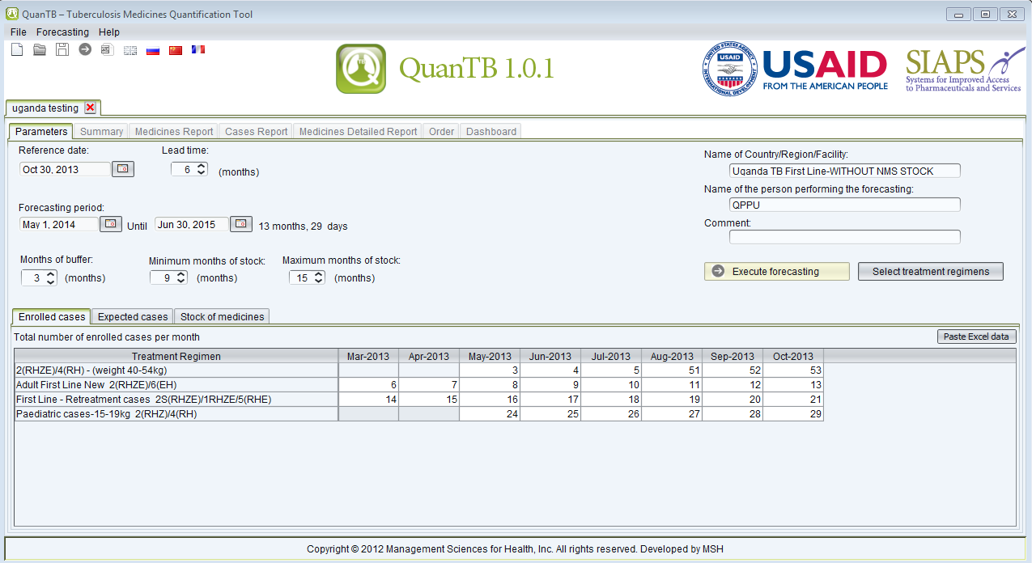

# Copy validation

## Not appropriated clipboard data

Suppose, that clipboard does not contain numeric data from the Excel. Error message will be raised:

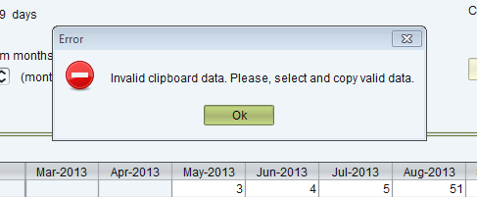

## Invalid columns

Suppose, that user does not copied all columns to the clipboard

|  |  |  |  |  |  |  |  |  |
| --- | --- | --- | --- | --- | --- | --- | --- | --- |
|  | Mar-13 | Apr-13 | May-13 | Jun-13 | Jul-13 | Aug-13 | Sep-13 | Oct-13 |
| 2(RHZE)/4(RH) - (weight 40-54kg) | 1 | 2 | 3 | 4 | 5 | 51 | 52 | 53 |
| Adult First Line New 2(RHZE)/6(EH) | 6 | 7 | 8 | 9 | 10 | 11 | 12 | 13 |
| First Line - Retreatment cases 2S(RHZE)/1RHZE/5(RHE) | 14 | 15 | 16 | 17 | 18 | 19 | 20 | 21 |
| Paediatric cases-15-19kg 2(RHZ)/4(RH) | 22 | 23 | 24 | 25 | 26 | 27 | 28 | 29 |

Error message will be raised:

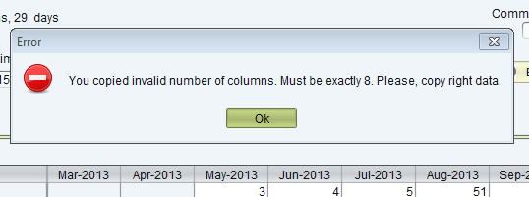

## Invalid rows

Suppose, that user copied too many rows – more than regimens in the forecasting.

|  |  |  |  |  |  |  |  |  |
| --- | --- | --- | --- | --- | --- | --- | --- | --- |
|  | Mar-13 | Apr-13 | May-13 | Jun-13 | Jul-13 | Aug-13 | Sep-13 | Oct-13 |
| 2(RHZE)/4(RH) - (weight 40-54kg) | 1 | 2 | 3 | 4 | 5 | 51 | 52 | 53 |
| Adult First Line New 2(RHZE)/6(EH) | 6 | 7 | 8 | 9 | 10 | 11 | 12 | 13 |
| First Line - Retreatment cases 2S(RHZE)/1RHZE/5(RHE) | 14 | 15 | 16 | 17 | 18 | 19 | 20 | 21 |
| Paediatric cases-15-19kg 2(RHZ)/4(RH) | 22 | 23 | 24 | 25 | 26 | 27 | 28 | 29 |
| Extra regimen | 30 | 31 | 32 | 33 | 34 | 35 | 36 | 37 |

Error message will be raised

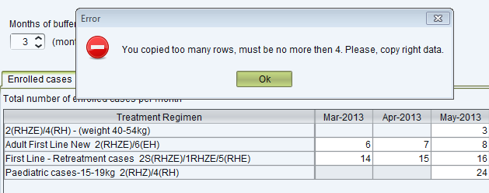

Note.

You can copy fewer rows. In this case fewer regimens data will be pasted. For example:

Copy quantities only for regimen 2(RHZE)/4(RH) - (weight 40-54kg)

|  |  |  |  |  |  |  |  |  |
| --- | --- | --- | --- | --- | --- | --- | --- | --- |
|  | Mar-13 | Apr-13 | May-13 | Jun-13 | Jul-13 | Aug-13 | Sep-13 | Oct-13 |
| 2(RHZE)/4(RH) - (weight 40-54kg) | 1 | 2 | 3 | 4 | 5 | 51 | 52 | 53 |
| Adult First Line New 2(RHZE)/6(EH) | 6 | 7 | 8 | 9 | 10 | 11 | 12 | 13 |
| First Line - Retreatment cases 2S(RHZE)/1RHZE/5(RHE) | 14 | 15 | 16 | 17 | 18 | 19 | 20 | 21 |
| Paediatric cases-15-19kg 2(RHZ)/4(RH) | 22 | 23 | 24 | 25 | 26 | 27 | 28 | 29 |

Let’s enrolled cases have such quantities

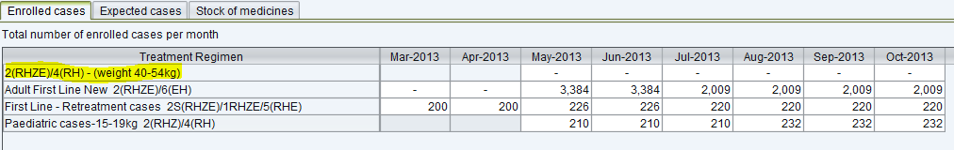

Press “Paste Excel data” button. Result will be

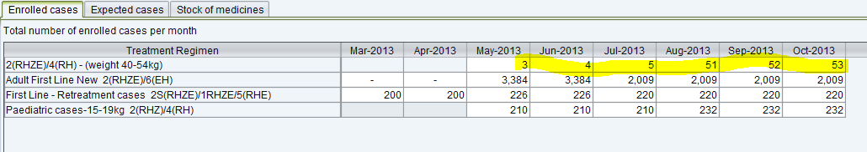

This kind of copy works only for “up-to-down” the sequence of the regimens in the forecasting. See “Restrictions” chapter below.

# Restrictions

## Weak validation

It will need a lot of accuracy for a user to copy and paste data correctly. It is no way to automatically determine does data belong to the particular regimen and/or particular month and year.

## The sequence of the regimens

The sequence of the regimens in Excel must be same as for QuanTB data. For example:

**Right:**

Excel data

|  |  |  |  |  |  |  |  |  |
| --- | --- | --- | --- | --- | --- | --- | --- | --- |
|  | Mar-13 | Apr-13 | May-13 | Jun-13 | Jul-13 | Aug-13 | Sep-13 | Oct-13 |
| 2(RHZE)/4(RH) - (weight 40-54kg) | 1 | 2 | 3 | 4 | 5 | 51 | 52 | 53 |
| Adult First Line New 2(RHZE)/6(EH) | 6 | 7 | 8 | 9 | 10 | 11 | 12 | 13 |
| First Line - Retreatment cases 2S(RHZE)/1RHZE/5(RHE) | 14 | 15 | 16 | 17 | 18 | 19 | 20 | 21 |
| Paediatric cases-15-19kg 2(RHZ)/4(RH) | 22 | 23 | 24 | 25 | 26 | 27 | 28 | 29 |

QuanTB data

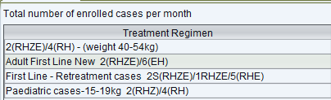

**Wrong:**

Excel data

|  |  |  |  |  |  |  |  |  |
| --- | --- | --- | --- | --- | --- | --- | --- | --- |
|  | Mar-13 | Apr-13 | May-13 | Jun-13 | Jul-13 | Aug-13 | Sep-13 | Oct-13 |
| First Line - Retreatment cases 2S(RHZE)/1RHZE/5(RHE) | 14 | 15 | 16 | 17 | 18 | 19 | 20 | 21 |
| 2(RHZE)/4(RH) - (weight 40-54kg) | 1 | 2 | 3 | 4 | 5 | 51 | 52 | 53 |
| Adult First Line New 2(RHZE)/6(EH) | 6 | 7 | 8 | 9 | 10 | 11 | 12 | 13 |
| Paediatric cases-15-19kg 2(RHZ)/4(RH) | 22 | 23 | 24 | 25 | 26 | 27 | 28 | 29 |

QuanTB data

