**For Multidrug:**

1. **Change labels to “Treatment Regimen” (not medicines or regimen only)**

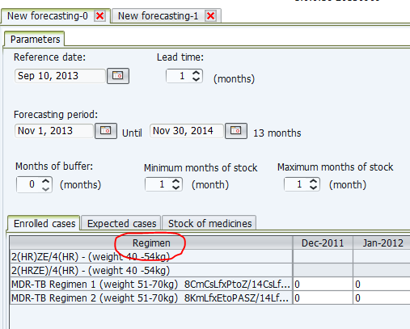

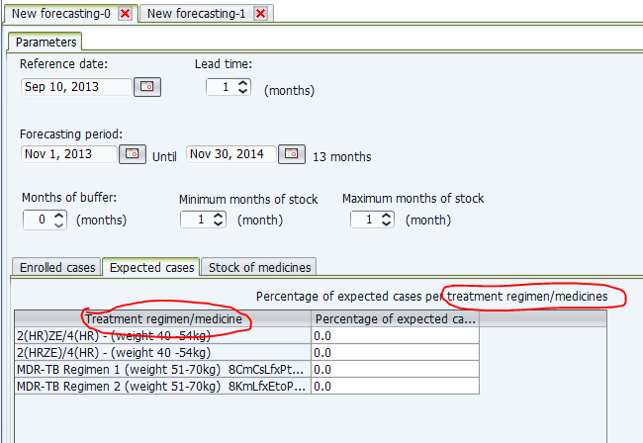

1. **For enrolled cases, include label “Total number of enrolled cases per month”, to guide users. Place as indicated below.**

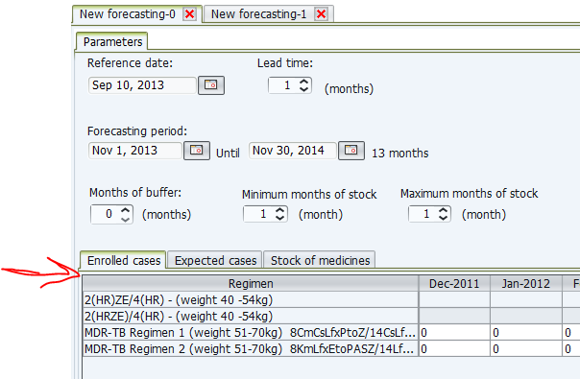

**For Single Drug:**

1. **Change labels to “Medicine” (not treatment regimen/medicine)**

