**For the Splash Screen and About (from file menu) use the same figure below.**

QuanTB

Tuberculosis Medicines Quantification Tool

e-TB Manager Quantification Tool

Copyright © 2005 Management Sciences for Health, Inc. All rights reserved.

Developed by MSH

**For the internal screens of the system use figure below with the remarks**

Change title to: **QuanTB – Tuberculosis Medicines Quantification Tool**

Menu bar will remain gray.

Make this background white. Even background for icons should be white.

Move the logo down into the white background.

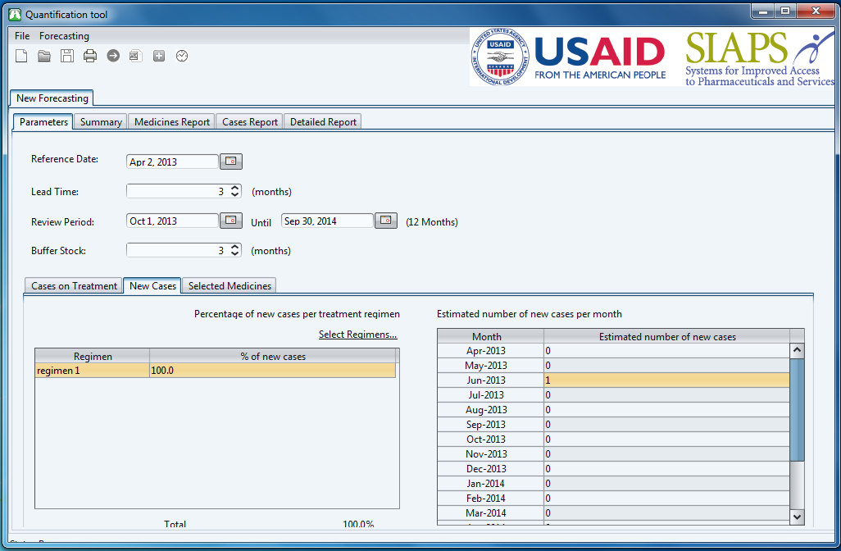

**REMARKS:**

**- White background on top between gray bar and start of tabs.**

**- Move logo to white space below grey header (menu bar)**

**Update the copyright at the bottom to:**

Copyright © 2005 Management Sciences for Health, Inc. All rights reserved.

Developed by MSH

**Make sure copyright is center justified. Keep the year in copyright message as 2005.**