Pharmadex, changes to processes proposal 2017-09-22

# Deficiency processing on review stage

NMRC wants a reviewer should able to submit the report, awaiting the response for the query from the applicant. The reason is the clarification could be something simple and in the meantime the secondary reviewer can supervise the work done by the primary reviewer.

# **Proposal:**

# Allow primary reviewer to submit result whether deficiency request exists or not.

**Questions:**

* Should we allow this for secondary reviewer as well?
* Should we allow Coordinator to pass application to Head in case unanswered deficiency request exists?

# Amendment processing

We agreed that, the system should only make provision for capturing the existing information and the new/ amendment. There is no need to capture the conditions to be fulfilled and documents to be attached as this will be reviewed manually.

In addition, Coordinator should has possibilities to inspect all amendments and to impact on amendment evaluation – add commentary and even return them to reviewers

**Proposal:**

Implement process like on diagram below

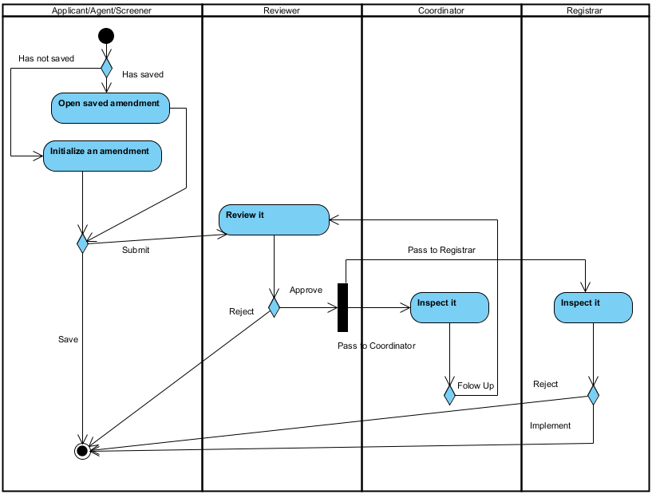

This diagram represents whole process. Only difference from current implementation is Coordinator. Please put attention on such particularities:

Applicant/Agent/Screener can create new amendment or using saved one

Reviewer has right to reject any amendment

To avoid excess bureaucracy, Coordinator and Registrar works concurrently. It means:

* If registrar decide to implement or reject and amendment, Coordinator lost access to it
* If Coordinator decide “Follow Up” an amendment, Registrar lost access to it

I believe that Coordinator and Registrar can communicate outside PharmaDex.

# Technical Evaluation Document

About a half of year ago, we decided do not use built-in Evaluation Report. Instead has been proposed to use MS Word file attached to Application. It is because PharmaDex lucks such possibilities:

* Define tables in any given reviewer’s answer
* Upload more than one image to any given reviewer’s answer

In other words, only formatted text and one image are possible for reviewer’s answer.

**Proposal 1:**

Use current available review questions and answers only for communicate between reviewers and coordinators. Technical Evaluation Document prepare in MS Word format and then attach it to Application. It is possible to automate creation of this document as we have implemented for Mozambique.

**Proposal 2:**

Allow uploading more than one picture. We have been implemented it for Mozambique, however using such trick:

* Each subsequent uploaded picture glued to picture from the database.
* Picture in database remains one.

**Proposal 3:**

Implement both proposals.

**Detailed Applicant Response will be removed in any case.**

# How to add image to review answer

Open a review answer as reviewer and add image file to it. It looks like below

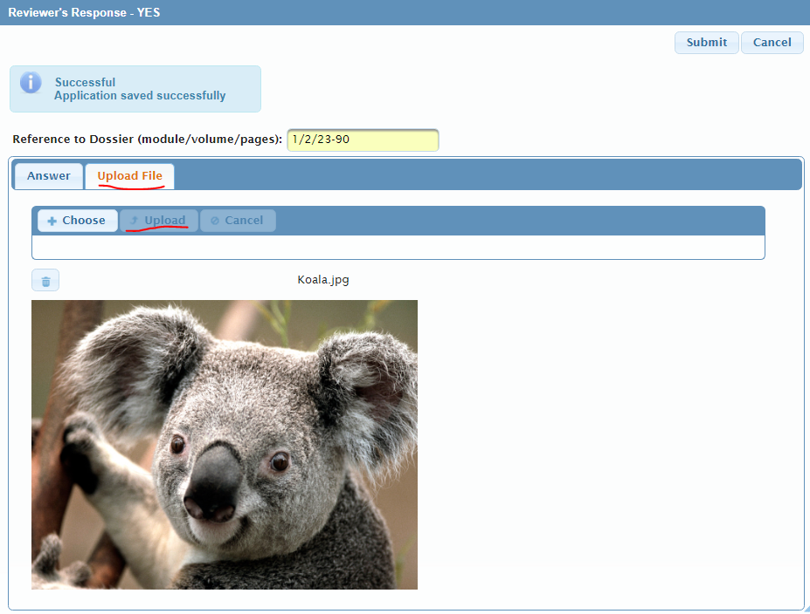

This picture will go to the Technical Evaluation report:

