|  |
| --- |
| **Performance Indicator Reference Sheet** |
| **IR 1: Pharmaceutical sector governance strengthened**  **Sub-IR 1.2:** Improved medicines policies, legislation, regulations, norms, and standards |
| **Indicator 1a: Average # of days taken to evaluate and approve regulatory applications** |
| **DESCRIPTION** |
| **Precise Definition(s):** Day count starts on the day the application is accepted as complete and duly filed and stops on the day the decision is made and communicated to the applicant. This is also referred to as regulatory review clock and does not include the days that the regulator stopped the clock because the regulator has requested and is expecting a response from the applicant. So the **Day count is equal to the total number of calendar days (minus number of days clock stopped, if applicable)**. |
| **Unit of Measure:** Calendar Days |
| **Disaggregated by:** N/A |
| **Justification/Management Utility:** This indicator provides average time in calendar days for a review of regulatory applications for product registration, import and export authorization, clinical trials, and promotional material application, etc. This indicator is important because access to health products and some health facilities begins with regulatory approval. Some health facilities, particularly manufacturers and Pharmacies, are not allowed to practice until their application to practice, import, export, etc. have been approved by the national regulatory authority. The timeline varies across the countries, depending on regulations, system, requirements, and capacity. However, NRA is accountable to review the applications, make decisions, and communicate with applicants within the expected timeline, to improve timely access to medicines and ensure their availability. According to WHO, medicine legislation should provide publicly available time limits for processing applications.[1] The indicator may also help to identify where the bottleneck and inefficiencies exist in the regulatory system in order to prevent unnecessary delays in getting the products in need to the market. |
| **PLAN FOR DATA ACQUISITION** |
| **Computation &**  **Example:**   |  | | --- | | Total # of calendar days taken to evaluate and approve/reject application for generic products received in the last 6 months  x 100 | | # of applications received for generic products during that period |   Note: the Denominator can be for all medicines or Generic products. If it is specific to generic product it needs to identify the generic and brand products in data capturing process so that two formula and two indicators can be generated. |
|  |
|  |
|  |
|  |
|  |
|  |

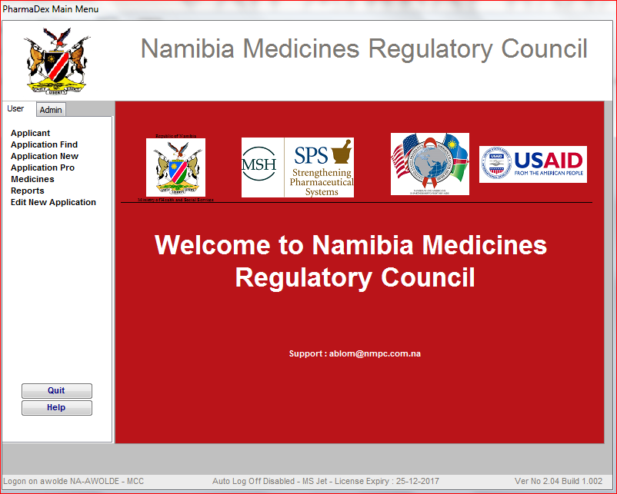

User Tabs

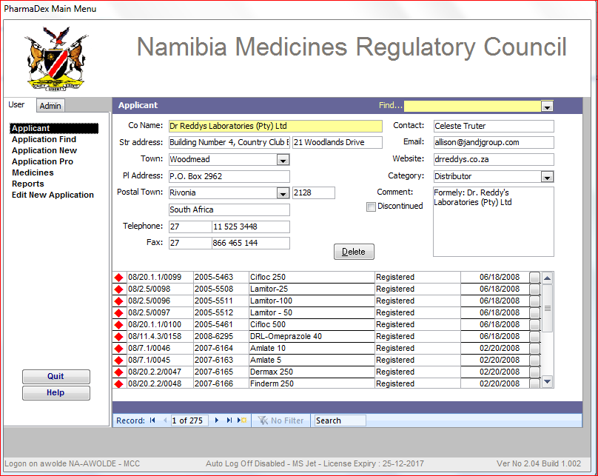

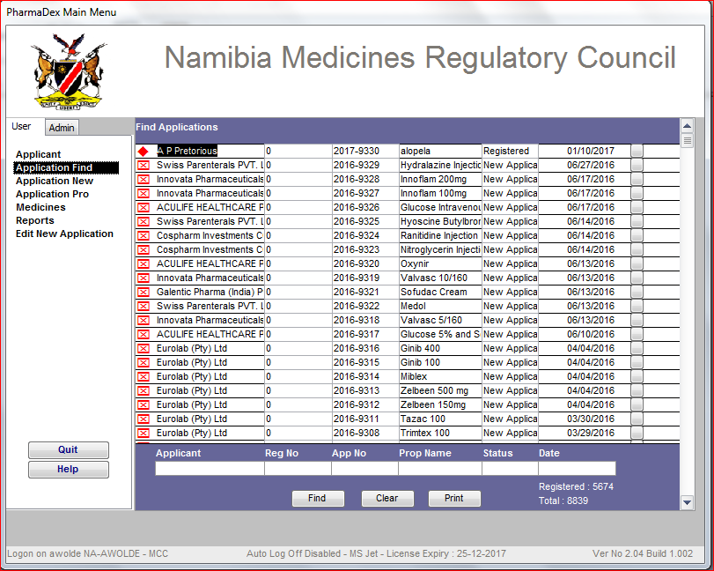

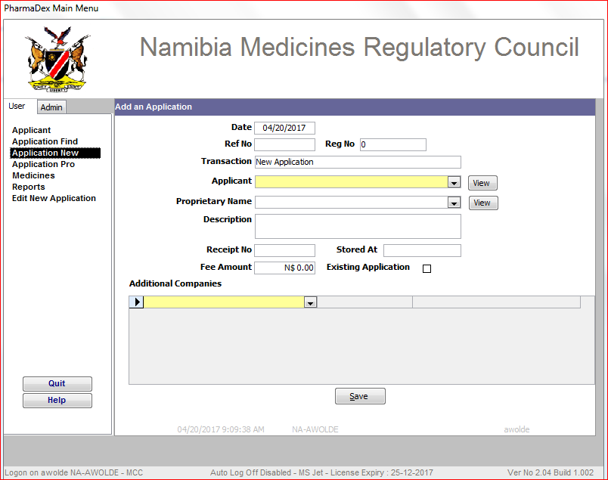

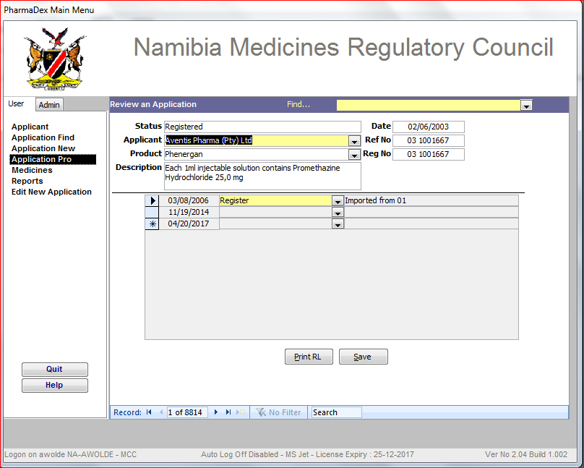

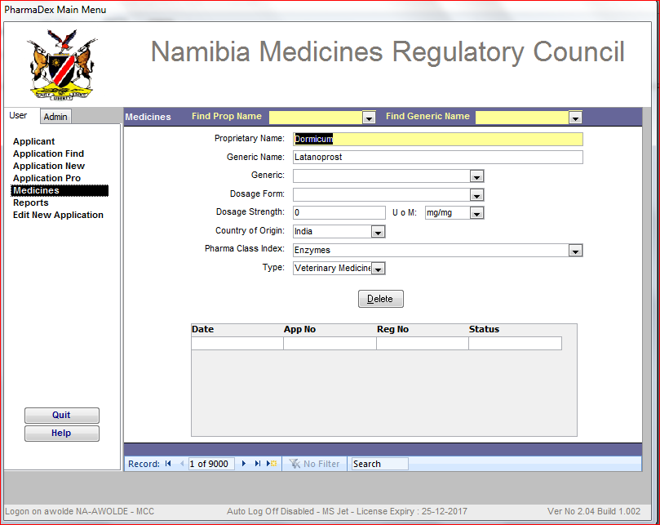

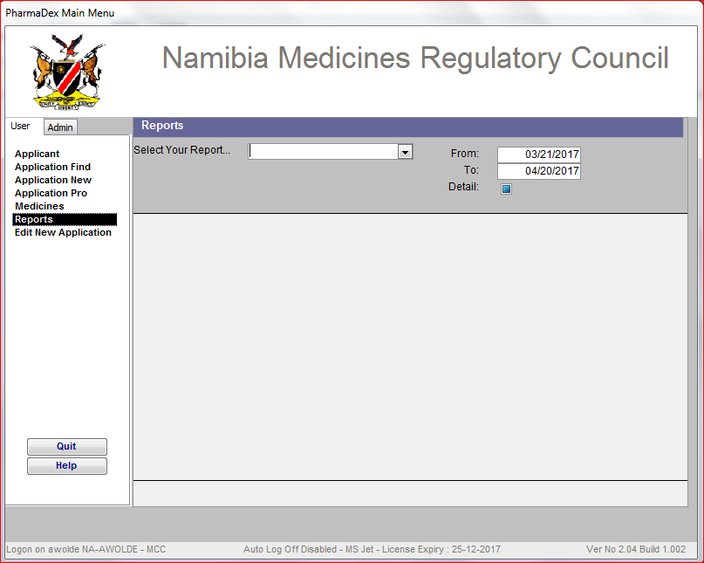

*Type of Reports*

* *01. Deleted Medicines*
* *02. Duplicate Companies*
* *Duplicate Medicines*
* *Duplicate registration numbers*
* *Medicines by Categories*
* *Applications received*
* *Application review status*
* *New Medicines added*

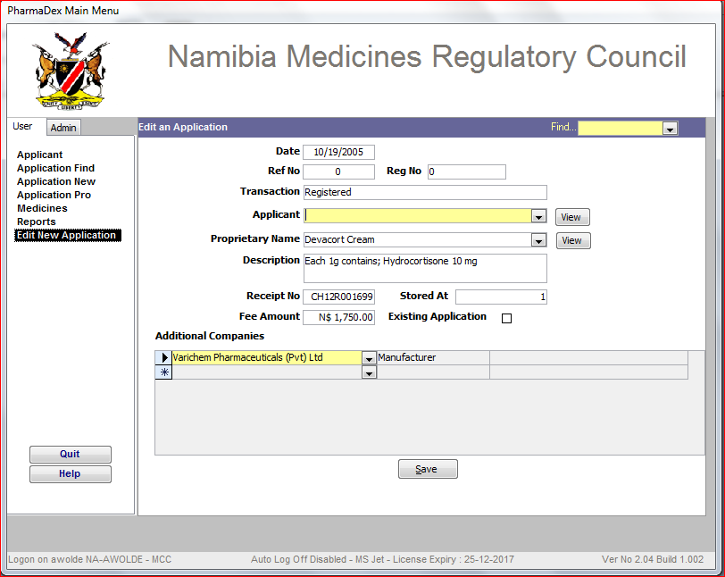

**Administration tab**

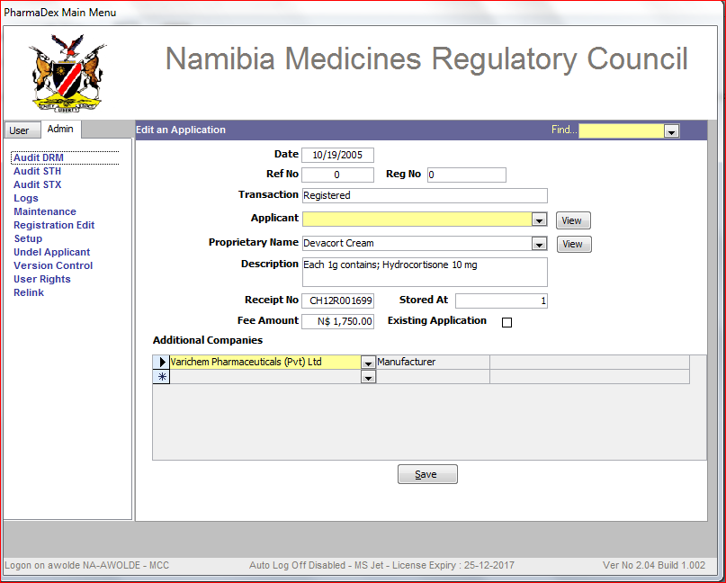

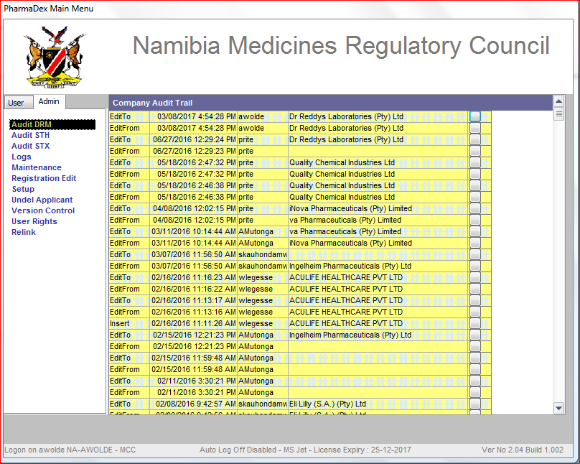

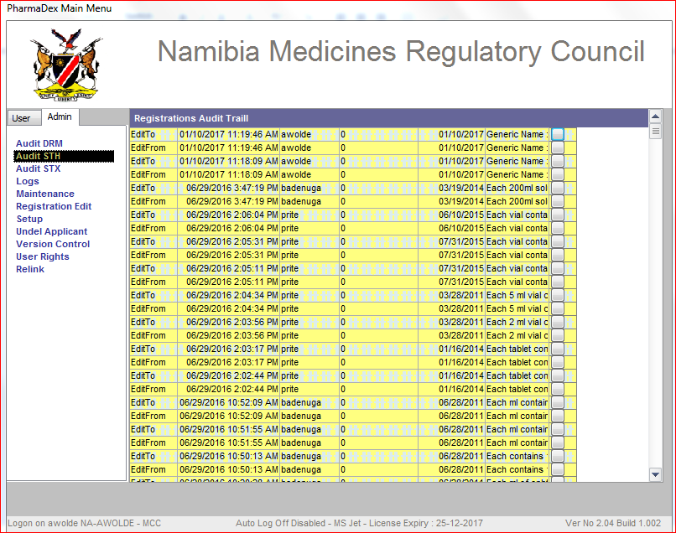

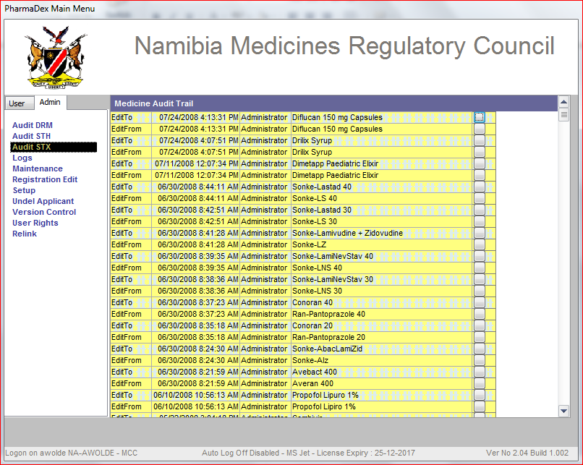

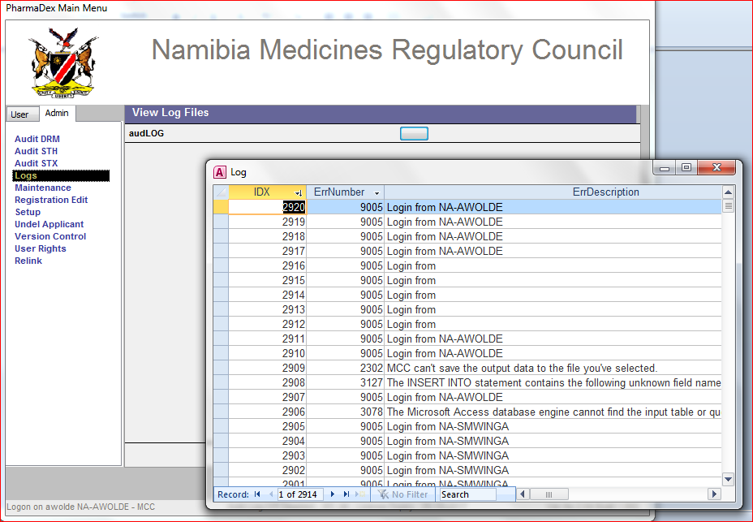

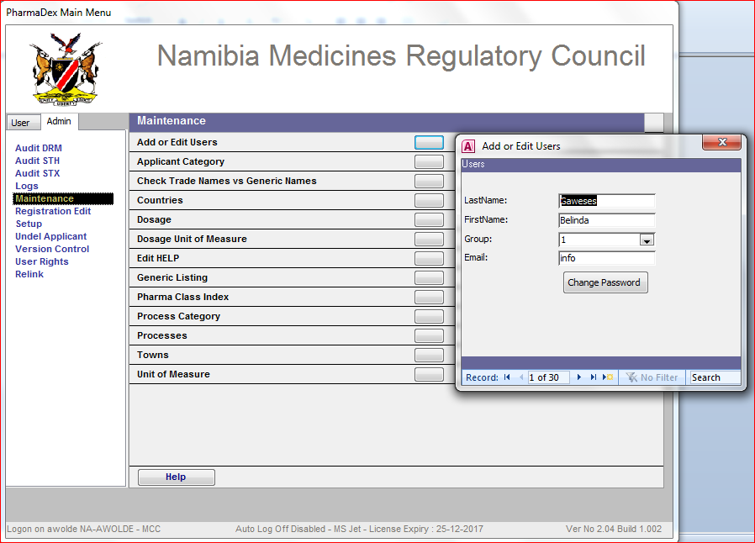

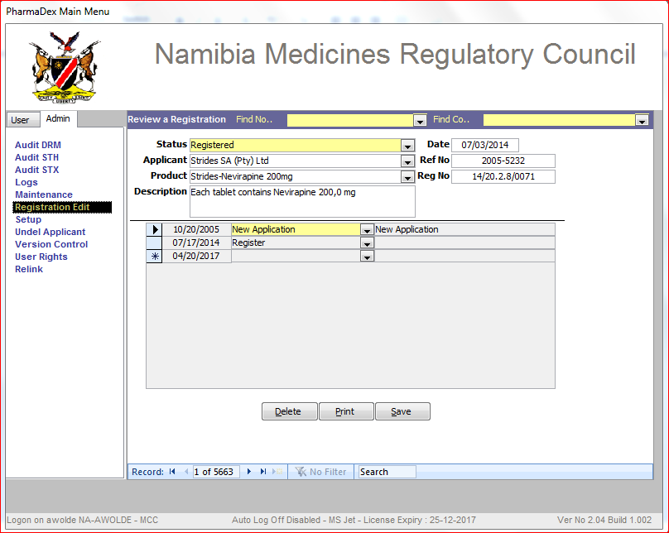

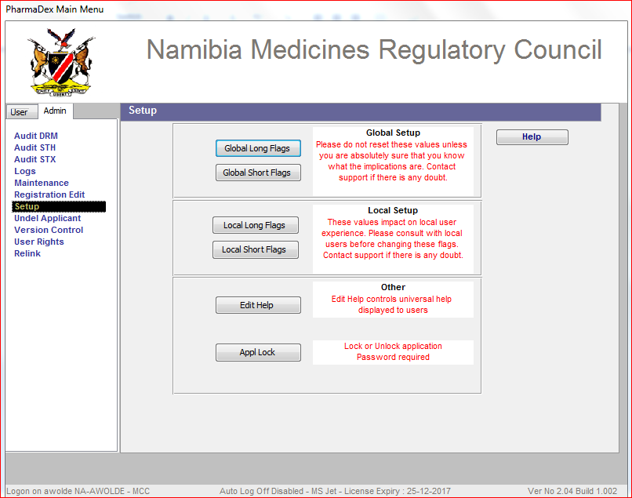

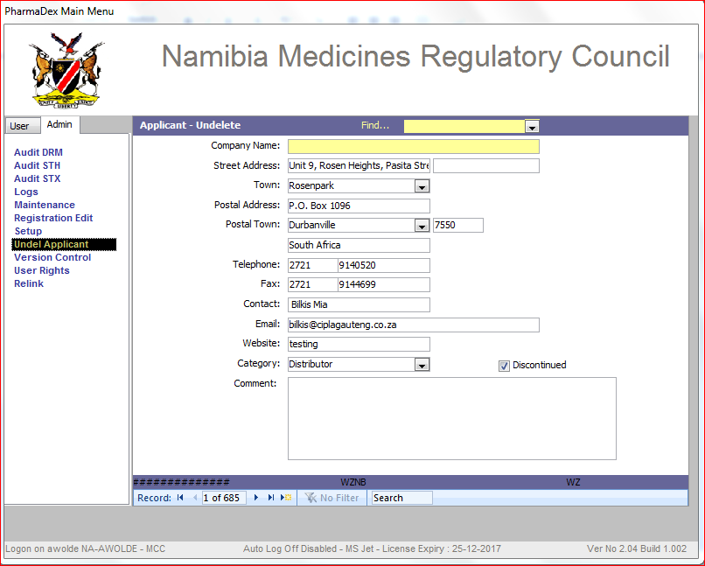

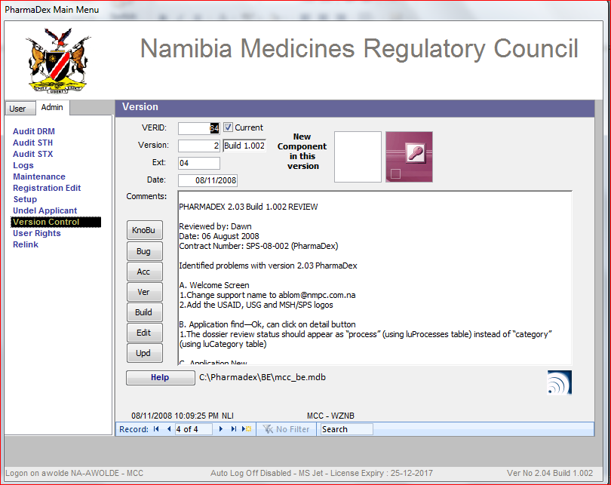

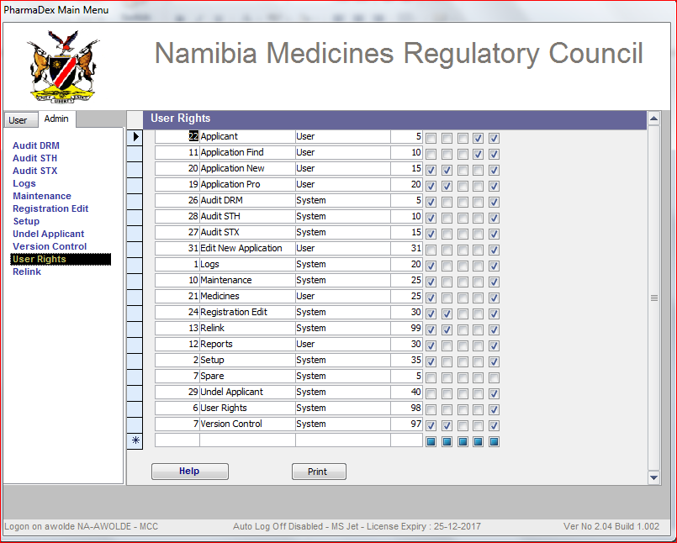

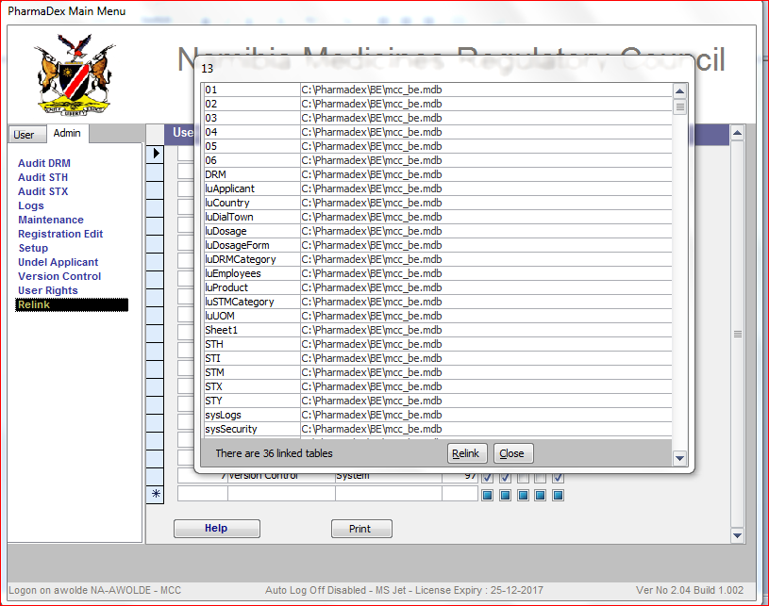

1. WHO. Measuring transparency in the public pharmaceutical sector: Assessment tool. 2009