Bangladesh Pharmadex issues from 22 Mar 2017

ToC
Preface 1
GUIDELINES FOR THE SUBMISSION OF BANGLADESH COMMON TECHNICAL DOCUMENT 1
General condition 1
Usage in Pharmadex 2
Where to use 2
How to use 2
IT team assistance 3
Review process 3
The guideline 3
Improvements 4
QoS Report 5
The guideline 5
Improvements 5
Quality Executive summary and Reviewer’s recommendations 5

Preface
This document intends to clarify Pharmadex issues found in version from 14 Mar 2017 and formulated at 22 Mar 2017.
For issues that do not need clarify, corresponding job orders are added to the Redmine. See Appendix A.

GUIDELINES FOR THE SUBMISSION OF BANGLADESH COMMON TECHNICAL DOCUMENT

General condition
There are two guidelines exists:
- CTD Module 1 (file 15-123 Bangladesh CTD Module 1.final.pdf)
- CTD Modules 2 and 3 (file 15-123 Bangladesh CTD Modules 2 and 3.final.pdf)
These guidelines intends to use by
- An applicant as source of dossier submission requirements.
- A screener as reference of dossier submission and appearance
- A reviewer as reference of detail requirements to dossier’s information

Usage in Pharmadex

Where to use
Pharmadex provides Screening Checklist template feature:
- For applicants – Checklist to check dossier content on one’s own, against actual dossier content requirements.
- For screeners
  - Checklist to check dossier content against actual content requirements.
  - Screening Deficiency Letter to inform an applicant about dossier content and/or appearance inconsistency
In addition, Administrator can use Screening Checklist Edit feature, to keep dossier content requirements up to date
Pharmadex provides Reviewer’s template feature for application reviewers that allows:
- Guide a reviewer through actual information requirements for each dossier module/chapter/sub-chapter
- Possibility to interact with applicants by Future Information requests
- Possibility to prepare Quality Summary reports that based on information requirements
In addition, Administrator can use Edit Review Questions feature, to keep review questions up to date

How to use
Administrator should use Screening Checklist Edit feature to prepare actual screening checklist. Basis should be taken from Table 1 on page 7 of 15-123 Bangladesh CTD Module 1.final.pdf. Pharmacologist experts (DGDA, MSH) should perform detailed elaboration.
Administrator should use Edit Review Questions feature to clarify current set of review questions. Basis should be taken from two sources:
- Guidelines for Module 1, 3
- QoS Review Template for Module 2.3, compared against Guide in 15-123 Bangladesh CTD Modules 2 and 3.final.pdf
For instance
Review Template | CTD Module 2.3
A. General Information | 2.3.S.1 General Information [Name, Manufacturer] (API)
B. Manufacture of API | 2.3.S.2 Manufacture [Name, Manufacturer] (API)
C. Control of API | 2.3.S.4 Control of Active Pharmaceutical Ingredient [Name, Manufacturer]
D. Characterization of API | 2.3.S.3 Characterization [Name, Manufacturer] (API)
E. Reference Standard | 2.3.S.5 Reference Standards or Materials [Name, Manufacturer]
F. Container Closure System | 2.3.S.6 Container Closure System [Name, Manufacturer]
G. Stability | 2.3.S.7 Stability [Name, Manufacturer]
H. Description and Composition of the pharmaceutical product | 2.3.P.1 Description and Composition of the Pharmaceutical Product
 | 2.3.P.2 Pharmaceutical Development [Name, Dosage Form]
 | 2.3.P.3 Manufacture [Name, Dosage Form]
 | 2.3.P.4 Control of Inactive Pharmaceutical Ingredients (Excipients) [Name, Dosage Form]
 | 2.3.P.5 Control of Pharmaceutical Product [Name, Dosage Form]
 | 2.3.P.6 Reference Standards or Materials [Name, Dosage Form]
I. Component of the pharmaceutical product
J. Container Closure System & other packaging | 2.3.P.7 Container Closure System [Name, Dosage Form]
K. Manufacture/Control of Drug Product | Are they 2.3.P.3 – 2.3.P.6 ?
L. Characterization of Impurities
M. Stability Testing of Finished Product | 2.3.P.8 Stability [Name, Dosage Form]
N. Appendices | 2.3.A Appendices

Pharmacologist experts (DGDA, MSH) should perform detailed elaboration.

IT team assistance
IT team can assist Administrator how to use Checklist Editor and Review Questions Editor in case of difficulties. Please do not hesitate to ask any questions related to editors usage.
IT team cannot assist pharmacologists and subject matter experts to detailed elaboration of Checklist and Review questions.

Review process

The guideline
Review guideline contains in Chapter 8.5 of DGDA Staff SOP (file Final SOP_PharmaDex_DGDA staff_JA_May2016_EM_ANM_JA-June2016.docx)
Table below contains Pharmadex features mapped to the guideline.
The guideline | Pharmadex
Reviewer is assigned by the Moderator to evaluate the different Modules of the dossier | Assign/Reassign reviewers feature provided to Moderator
Logs into PharmaDex with their user name and password to evaluate the application | General login feature
Access the dossier from the shared folder with their password and review the documents | Outside Pharmadex
Reviewers’ evaluates the dossier and generate evaluation reports consisting of (Applicant answers, Reviewers comments, and recommendations; deficiencies if any, summary; etc.) using the Reviewer’ Template in PharmaDex | Menu Application Processing – Review Applications  Reviewer’s template  Review report screen form  Reviewer’s Response dialog form
Once the Reviewer completes the evaluation of the dossier, it is sent to the assigned Moderator for a revision | Submit button on Review report screen form
Reviewer waits for the Moderator to review the evaluation reports consisting of (Applicant answers, Reviewers comments and recommendations; deficiencies if any, summary; etc.)
If Moderator agrees with the Reviewers evaluation reports, recommendations; deficiencies; etc., generates an Executive Summary and the application is passed on to the Head | Executor Summary button on Application Evaluation screen form (tab Assessment)
However, if the Reviewer has some concerns with the Moderators’ assessment of the reviewed reports (recommendations, deficiencies; or have their own concerns; deficiencies; inputs; need for more information/documents; etc.) the application is sent back to the Moderator with specific reasons | Pharmadex require full consensus between all reviewers and Moderator  Deficiency report feature suspends review process until reply
In addition, the Reviewer can request to meet with the Moderator to discuss the application further | Outside Pharmadex
Reviewer then proceed with another evaluation of the dossier based on the feedback from the Moderator and discussions, if applicable and then send the report back | Moderator can asks for feedback from all reviewers.
Reviewer should ensure that the quality test sample request sent to NCL has been analyzed, report have been sent by NCL via PharmaDex and the results are acceptable
If sample report is not acceptable, further information should be requested from NCL, until the report is acceptable | Sample request feature on Application Evaluation screen, accessible by Moderator

Improvements
The guideline | Improvement | Job order # (Redmine) | Due Date
Reviewers’ evaluates the dossier and generate evaluation reports consisting of (Applicant answers, Reviewers comments, and recommendations; deficiencies if any, summary; etc.) using the Reviewer’ Template in PharmaDex | Remove N/A as valid answer on review question | 2546 | Mar 24
 | Reviewer’s Response dialog form should reflect question data (like – A. General Information, B. Manufacturer API etc) | 2547 | Mar 24
 | Paint red Reference to Dossier (module/volume/pages) field when validation did not pass | 2548 | Mar 24
If sample report is not acceptable, further information should be requested from NCL, until the report is acceptable | Allow Sample request feature for Reviewer, directly from Review report screen form as an additional tab | 2549 | Mar 24

QoS Report

The guideline
Unfortunately, the SOP mentioned above does not cover form and usage of this report. However, we have the report template represented as file “Revised Final Quality Review Template_V1.docx”

Improvements
Requirement asked by BD Team | Improvement | Job order # (Redmine) | Due Date
The review template letter I sent you for upload please do exactly what it mentioned | Clarify what is exact requirement | 2550 | Mar 24
Only one Review letter should be generated by the one reviewer | Impossible, because of software limitation.
Please see the attached file for change in the pop up bar after reviewer submit, it will be changed as satisfactory and unsatisfactory. The comment section will be the Executive Summary from the reviewer | See above. | 2546, 2547, 2548
In accordance with the SOP chapter 8.5 Reviewer may input only following:
- Reviewer’s comment for each question
- Reviewer’s recommendation for whole review.
Executive summary is for Moderator only.
Reviewer’s comments and recommendation are in right place of the template (see below). Please check it.
 | Make string "OVERALL QUALITY REVIEW RESULT" in one line | 2552 | Mar 24
For all your kind attention and information: Please go through the Guidelines and SOPs attached here for better understanding of CTD and the system. Our PDX system is the reflection of the Guideline for Bangladesh specific. | See above (GUIDELINES FOR THE SUBMISSION OF BANGLADESH COMMON TECHNICAL DOCUMENT)
The questions from Module 1 also generated in the review template automatically, it should not come in the letter. If reviewer wants to write anything from module 1 he/she can write in the executive summary. | Restrict QoS template only to Module 2 | 2551 | Mar 24
One Bug also found in the system, please see the attached files | Please, clarify what do you mean | 2550 | Mar 24

Quality Executive summary and Reviewer’s recommendations
There is no room for Quality Executive Summary it on the first page, because Reviewer’s comments (recommendation) may be a long list
For instance
The template | Real QoS
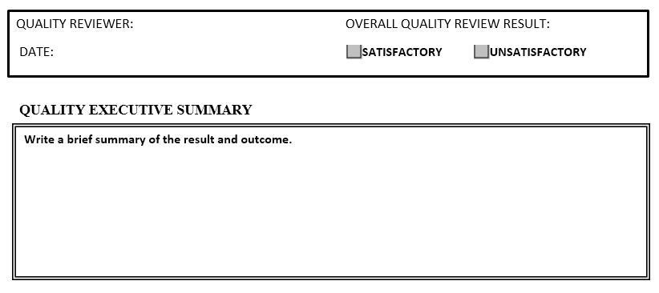 | 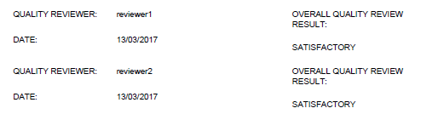

Reviewer’s comments are in a right place
The template | Real QoS
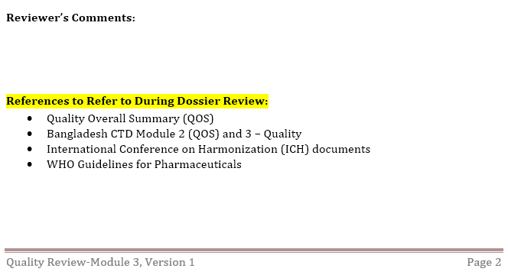 | 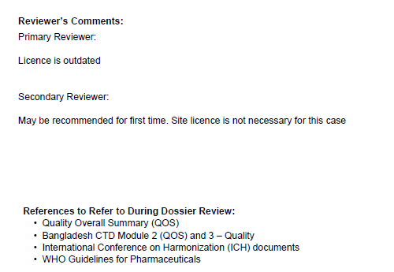
In addition, Quality Executor Summary may be a long text up to one page, as well as any Reviewer’s comment.

