How to initiate and track a review (Bangladesh only)

Assume that user is Moderator.

# Where to begin

Open Application Processing – Process Product Application

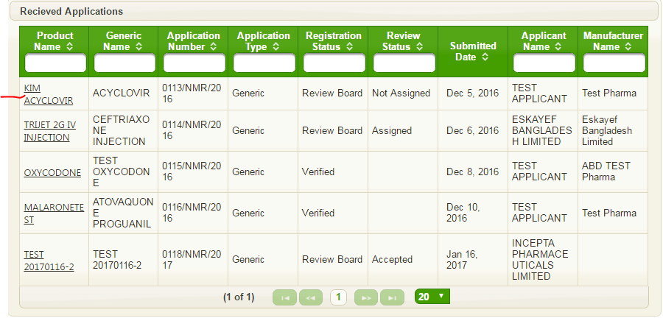

Open an application and select Assessment tab

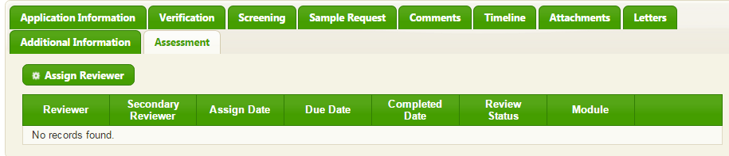

# How to assign reviewers

Press, “Assign reviewer” and fill form

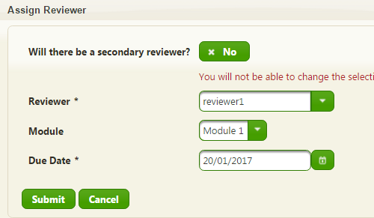

Press Submit

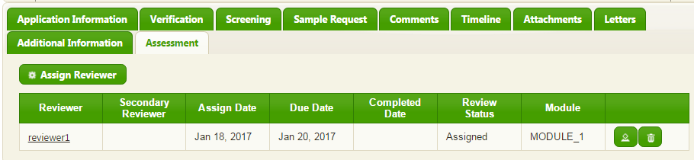

Add the same reviewer for second module

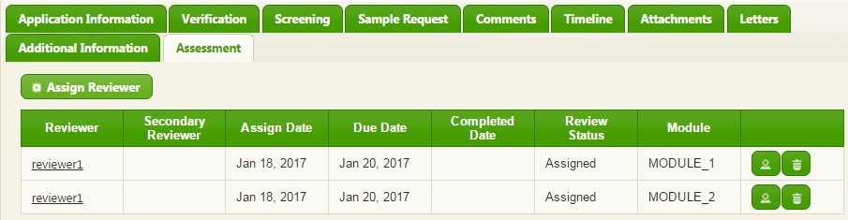

For exercise only, assign reviewer2 and reviewer 3 will act as Primary and Secondary for module 3

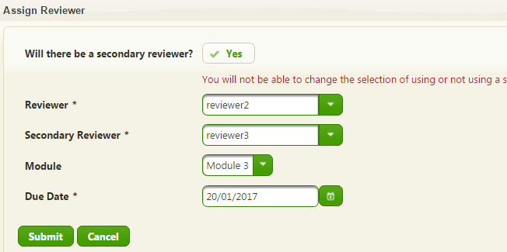

Press Submit

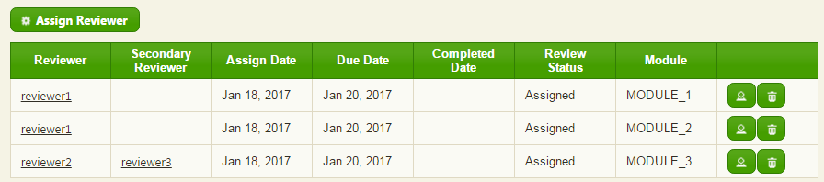

Assign reviewer 3 for module 4

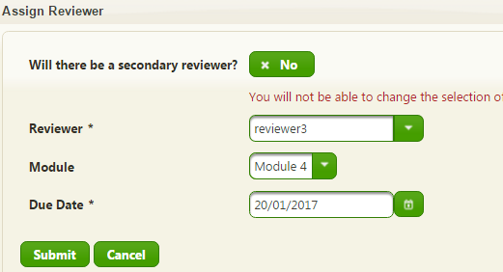

Press Submit

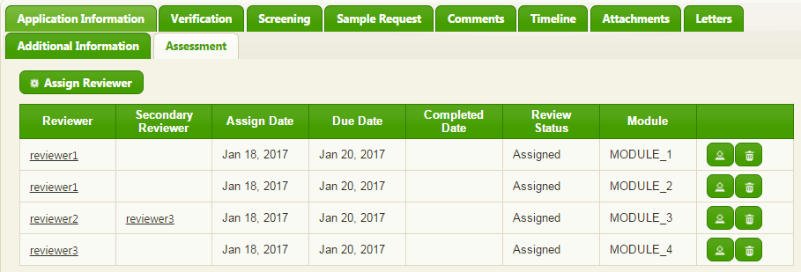

# How it works for reviewers

Suppose, we have assignments from example above. Just after assignment, reviewers will receive following job orders

|  |  |
| --- | --- |
| Reviewer | Module |
| Reviewer1 | Module_1 |
| Reviewer1 | Module_2 |
| Reviewer2 | Module_3 |
| Reviewer3 | Module_4 |

Please, put your attention that only primary reviewers will receive job orders. For instance:

Reviewer1 has two job orders for Module_1 and Module_2

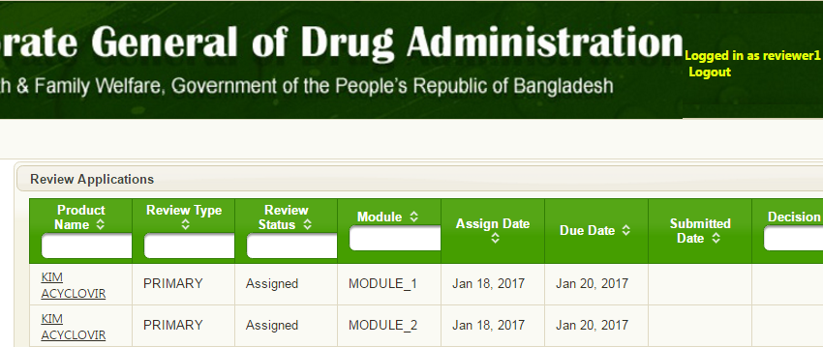

Reviewer3 has only one job order

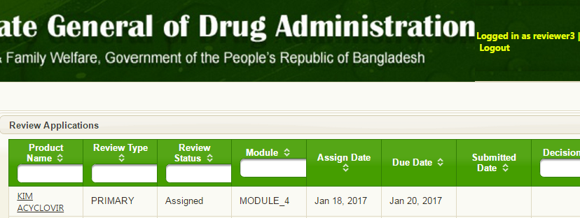

All primary reviewers can work concurrently or sequentially

Primary and Secondary reviewers can work only sequentially – Primary, then Secondary.

# How to track review

## Suppose reviewer1 and reviewer3 have done primary reviewer’s job.

Application is still in Review Board State

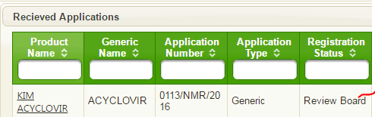

Assessment tab will looks like

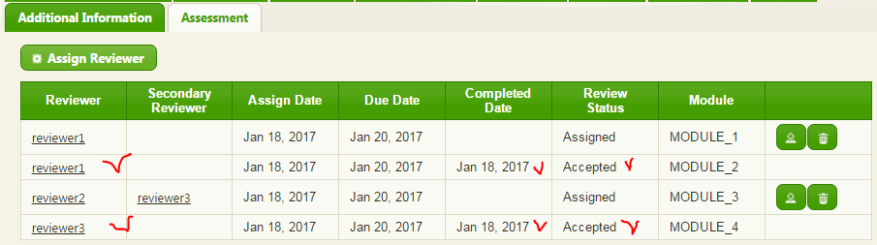

### Suppose all primary reviewers have done their job

Application is still in “Review Board” State



Assessment tab looks like

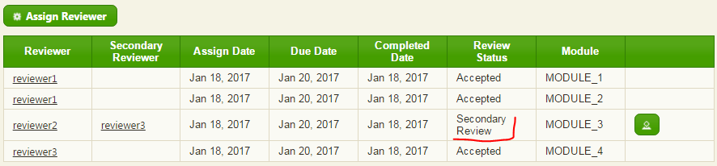

Reviewer3 has job order for Module_3 as secondary reviewer

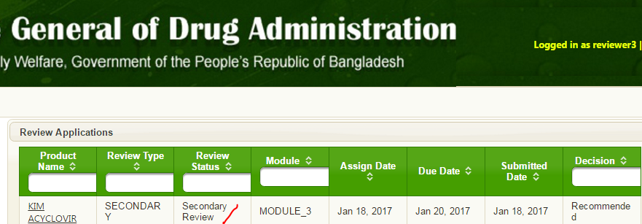

### All reviewers done their job

Application id still in “Review Board” state, however review status is “Accepted”

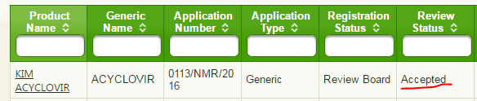

Assessment tab looks like

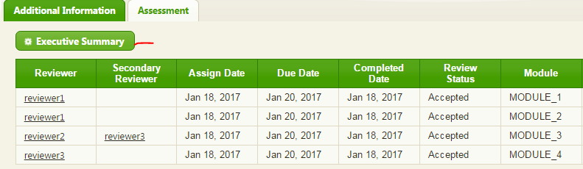

Please. Put your attention that only in “Accepted” status Moderator can do “Executive Summary”