Legacy data import how to.

# Objective

1. Place to the database actual data about registered products.
2. Clarify information about applicants – addresses of existed in the database and add new ones.
3. Clarify information about manufacturers – addresses of existed in the database and add new ones.
4. Clarify information about active ingredients – add new ones

# Data sources

MS Excel file Planilha Registo MSH.xlsx that contains actual data about registered products, applicants, manufacturers and active ingredients. Hereinafter referred to as **Register**.

The current Pharmadex database that contains information about product’s formulary numbers. Hereinafter referred to as **Database.**

# Clarification

## Applicants

Currently Pharmadex is on regular duty. Therefore, it is impossible to clean all applicants from the database and insert new ones. We can only:

* Insert applicants that exist in the Register, but not exist in the Database.
* Update addresses from the Register for applicants that exist in both Database and Register.

Applicant’s data takes from two sources:

* Columns E and F from the Register (name and address respectively)
* Applicant’s data from the Database

The problem is to establish correspondence between applicants in the Database and applicants in the Register. It is possible only by names, but it is possible that names for any particular applicant will be slightly different in the Register and in the Database. Therefore, it is necessary to perform manual job to establish this correspondence.

Result is in file applToClean.xlsx.

## Manufacturers

Same as for Applicants. Only difference that a manufacturer always has correspondence of a country. This correspondence may be established only by country name. It does not work for all cases. For all manufactures, country name will be written to the field Address 2 as this name defined in the Register.

Result is in manufToClean.xlsx.

## Active ingredients

For each product, the register contains definitions of active ingredients. It is a good idea to extract all active ingredients names from the Register and verify them. The verification allows to fix spell errors and to reduce duplication.

Result is in INNToClean.xlsx

## Formulary numbers

The Register does not contain Formulary numbers. This information is important and must be saved before import.

Result is in prodFNM.xlsx

# Updates

## Applicants

Applicant’s update consist of three files:

1. applicants.sql – insert and update SQL statements
2. applicants_del.sql - allows delete all inserted appllicants is something will go wrong
3. applicants.xlsx - references to applicants, that will be used internally to build products update

Any applicant will be registered for country Mozambique and as Importer.

## Manufacturers

Manufacturers update consist of three files:

1. manufacturers.sql - insert and update SQL statements
2. manufacturers_del.sql - allows delete all inserted manufacturers is something will go wrong
3. companies.xlsx – references to companies (manufacturers), that will be used internally to build products update

## Active ingredients

Active ingredients update consist of three files:

1. inn.sql – insert SQL statements
2. inn_del.sql - allows delete all inserted ingredients is something will go wrong
3. inn.xlsx - references to active ingredients, that will be used internally to build products update

## Products

Products update consist of three files:

removeProduct.sql – SQL script to remove from the database products that been created before 2016-07-31 (old import and tests)

products.sql – SQL script to insert registered products from the Register. In addition for each product:

* Creates registration applications
* Established relation to active ingredients
* Established relation to the manufacturer

products_del.sql - allows delete all inserted products and applications is something will go wrong

# Execute update

## Pre – conditions

Update may take up to two hours. While update the system will be inaccessible for users.

Update must be executes only when the system is not accessible for users. Stop Apache HTTPD server before update.

Back up the database by execute backup.cmd script manually from directory c:\backup on the database server. New backup file with name YYYYMMDDpdx_mz.sql must be created.

## Sequence

Copy all updates to some folder on the application server. For instance:

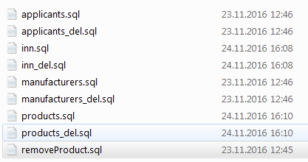

On the application server start MySQL workbench



Open script removeProduct.sql

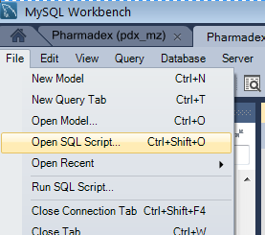

Run it, will take a while…

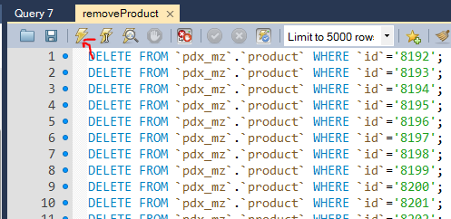

Open script applicants.sql and run it

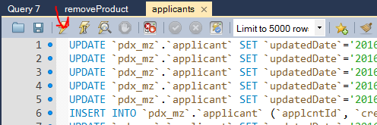

Open script manufacturers.sql and run it

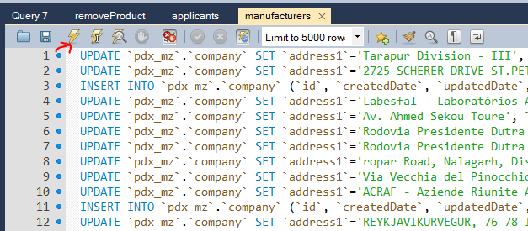

Open script inn.sql and run it, will take a while…

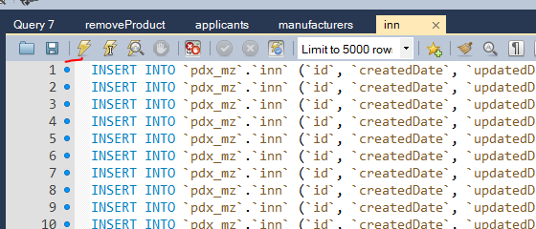

Open script products.sql and run it, will take a lot of time!

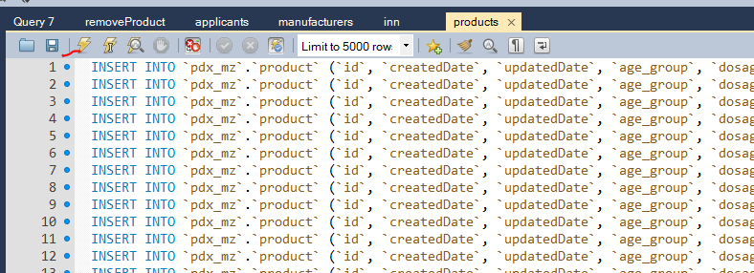

Run Pharmadex locally on the Application server and ensure that import completed successfully

To check it, please open registered products list

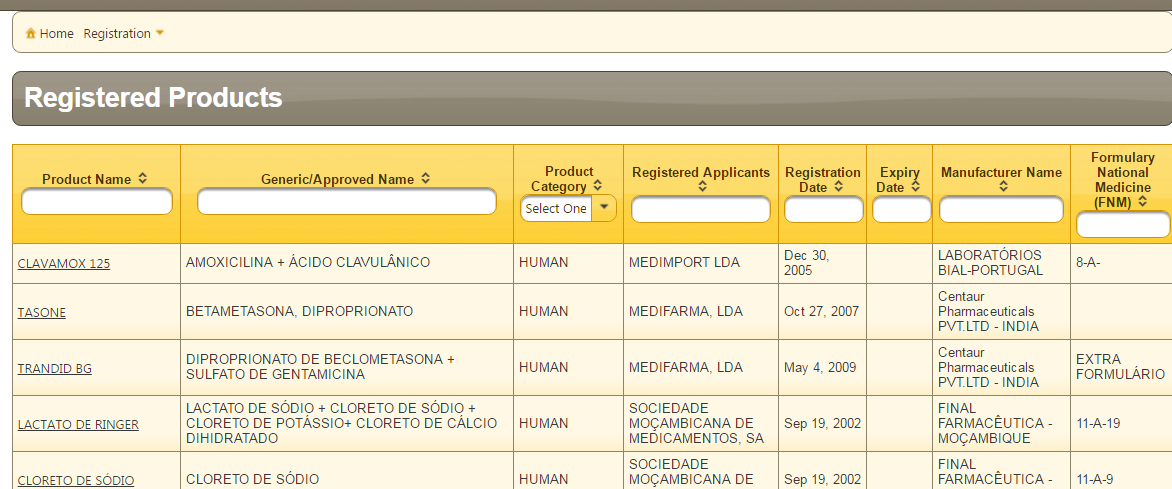

# Result description

All products that registered before Jul 31 2016 will be deleted. These records seems as result of previous data import.

All products from the Register with word “Autorizado” in column AK have been imported to the database. Unambiguous automated import currently is possible for following data from the Register:

|  |  |  |
| --- | --- | --- |
| **Column** | **Column Header** | **Database** |
| E, F | Name of importer, Contact Information | Applicant |
| G | Brand Name | Proprietary name (brand name) |
| I | Generic Name | Generic Name |
| K | Quantity of active ingredient | Dosage/Strength |
| D | Aplication Type | Application Type |
| T | Presentation | Pack size |
| X | Shelf life | Shelf life |
| Y | Storage Condition | Storage Conditions/Climate Zone |
| Z | Product Category | Product Category |
| AE | Proposed Indication for Use | Proposed Indication for Use |
| AF | Posology | Proposed Posology and Method of Administration |
| AG | Age Group | Age Group |
| AH | Product Description | Product Description and Physical Appearance |
| AO | Reg_date | Registration date |
| AN | Product License Number | Product registration number |
| C | Process Number at Excel Registration Data Base | Application number |
| AA, AB, AD | Name of manufacturer of finished product, address and country | Finished product manufacturer |
| J | Active Ingrient Names | List of active ingredients |

Ambiguous data in the Register that requires additional manual intervention to make them unambiguous. All these interventions are possible after first import.

|  |  |  |  |
| --- | --- | --- | --- |
| **Column** | **Column header** | **Database** | **Intervention** |
| L,M | Quantity of active ingredient, Unit of active ingredient | Same for each Active ingredient | Manual input as need and while re-registration |
| O | Inactive Ingredients Names (Excipients) | Inactive Ingredients for a product | Manual input as need and while re-registration or establish manually correspondence between excipients names in the Register and excipients names in the database |
| P,Q,R | Specification of inactive ingredient, Quantity of inactive ingredient, Unit of inactive ingredient | Excipients for a product | Manual input as need and while re-registration |
| S | Dosage Form | Dosage Form | Manually establish correspondence between dosage form names in the Register and dosage form names in the Database (about 200) |
| V | Route of Admin | Admin route | Manually establish correspondence between admin route names in the Register and admin route names in the Database (about 100) |
| W | Pharmaceutical Classification | Pharmacological Classification | We need something to do with it! Data in the Register and in the Database un corresponding. |
| AP | Exp_date | Registration expiry date | Empty in the Register. Is it possible to calculate it based on reg date (AO column) |