1. **Text and images to be removed**
   1. **Home page**

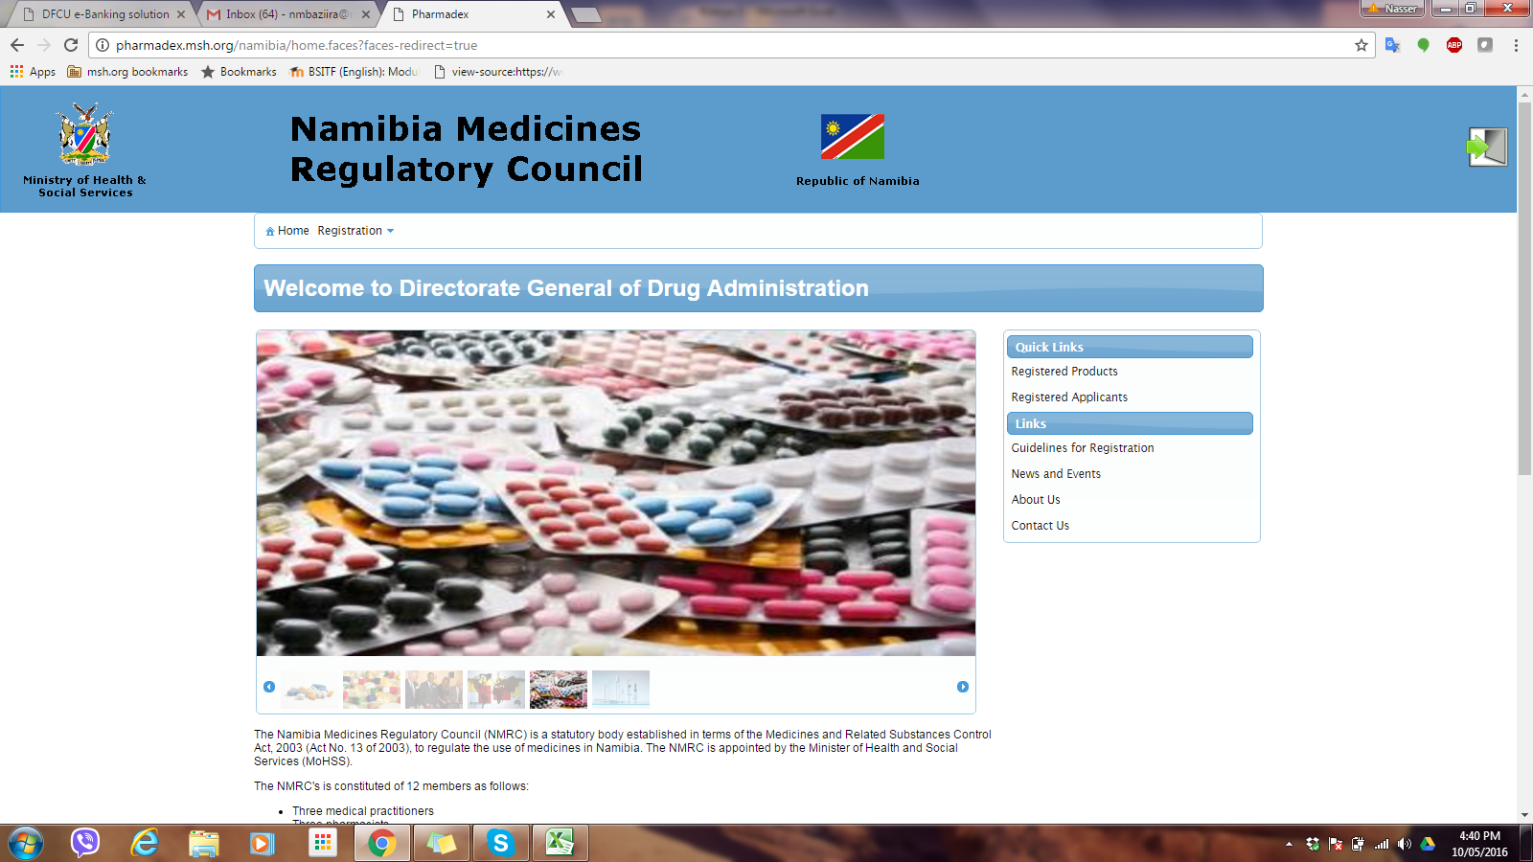

Remove texts and images – this information will provided on the NMRC website; [www.nmrc.com.na](http://www.nmrc.com.na)

Not for Namibia - Delete

* 1. **Home page >> Registration**

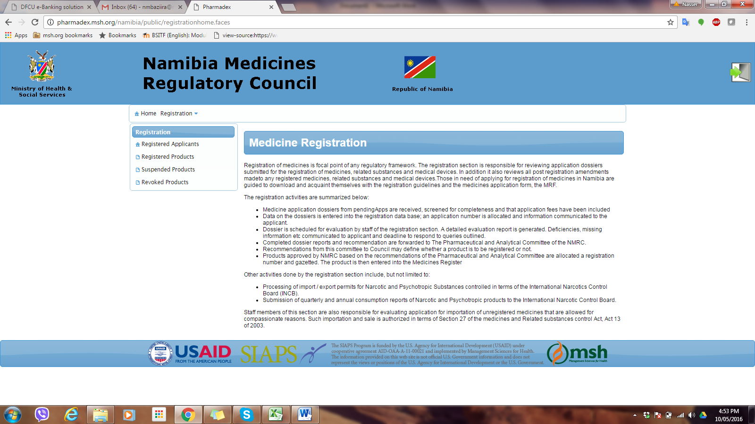

Remove texts and images – this information will provided on the NMRC website; [www.nmrc.com.na](http://www.nmrc.com.na)

1. User registration/sign up

* The users should be able to apply for login details by filling the Applicants registration form accessible from the home page. Authorization is only granted by the NMRC administrator on review of application.

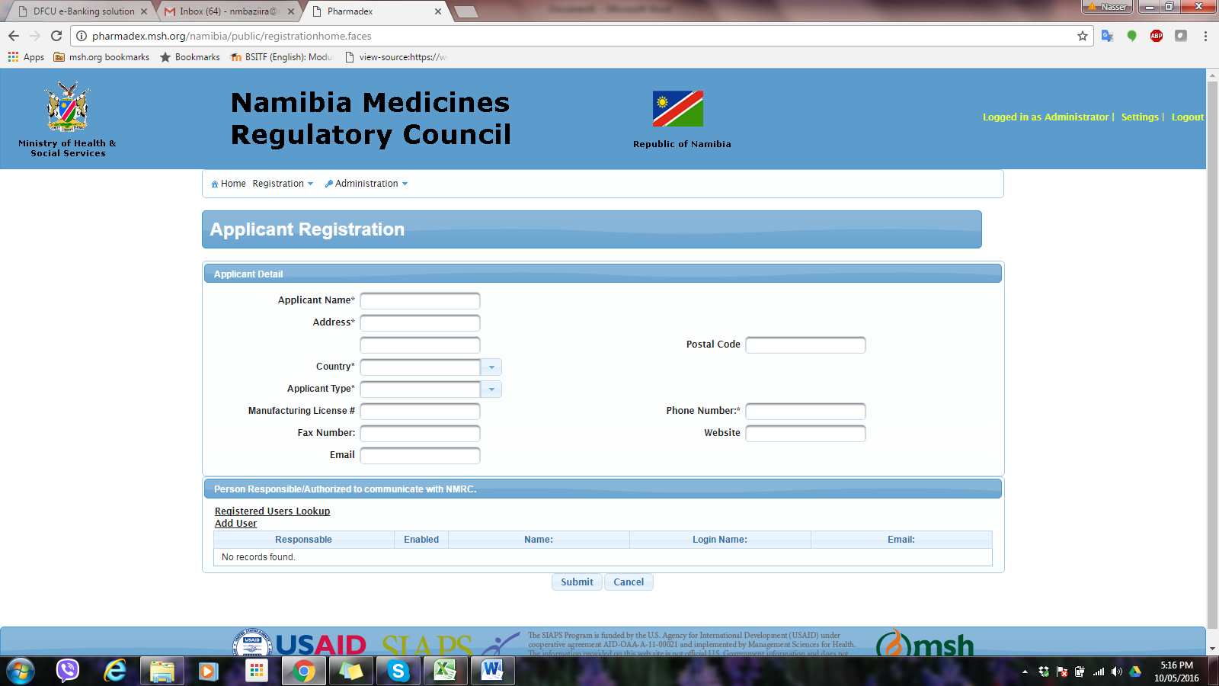

‘Applicant’ refers to a firm. And each firm should have registered users who login into the app to submit or check status of their applications

1. Product registration

Product Proprietary Name should not be mandatory since some products may be presented as generics

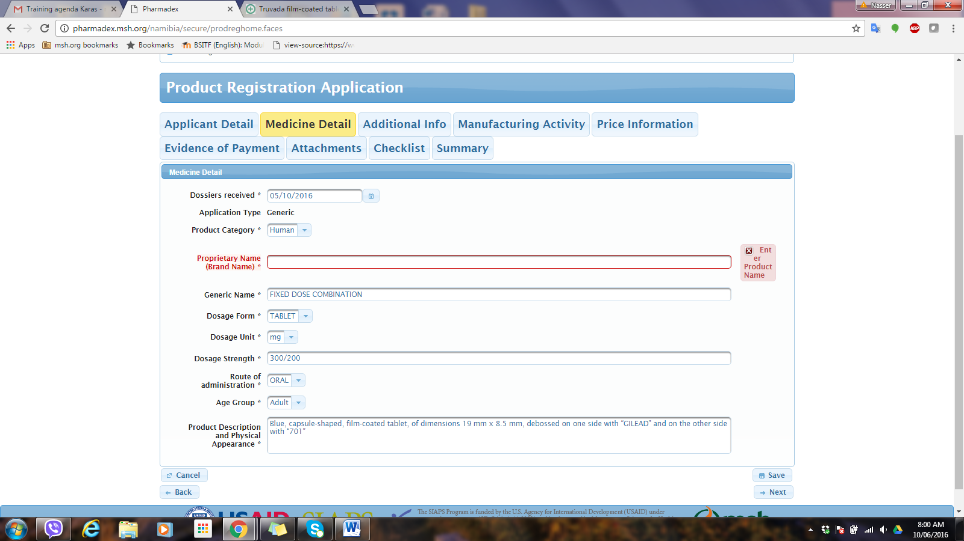

Insert guidance: “Mandatory field, enter generic name where there is no Proprietary Name”

1. Screening

The person with the roles of screening/receiving may not see the following tabs: Forms, Current applications. The processing tab is more relevant

The checklist seen under screening allows upload of documents. It would be good if the applicant has this option also and the person screening/receiving can only download to verify if right documents are provided. Currently the applicant only checks off with no option to upload

