Please move the name of the Applicant to the same line with the DIRECTOR TÉCNICO

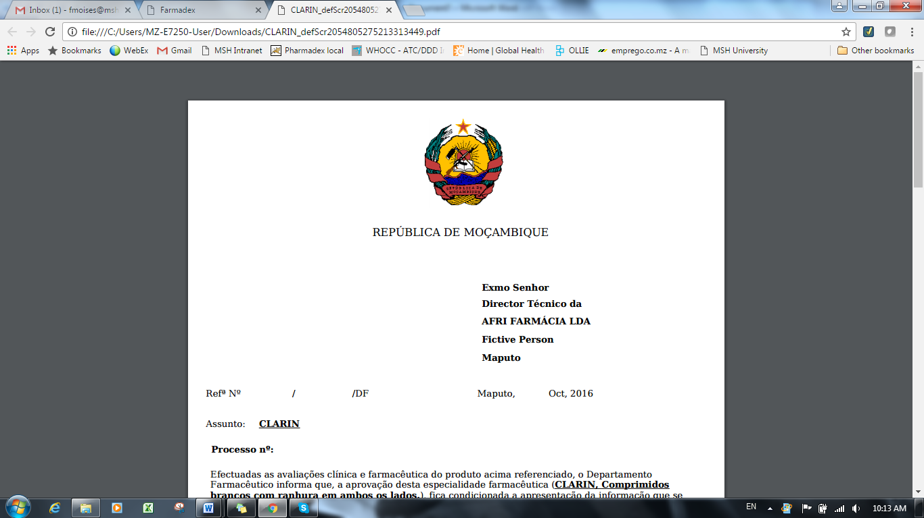

The subject of the Letter should be **Pedido de Elementos para o Produto XXXXXX** (Name of the Product)

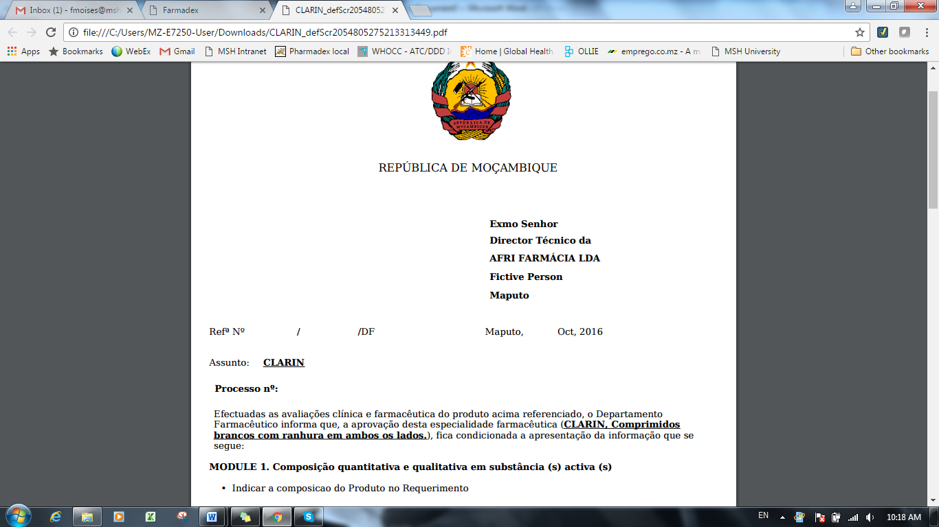

The Month of the date, should be in Portuguese and Complete for example**: Maputo, 03 de Outubro de 2016**

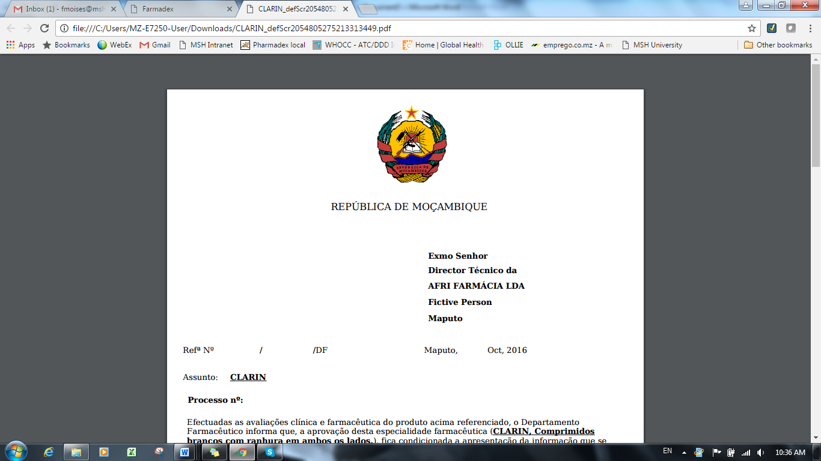

Please remove the modules and put only the comments of the screener from Remarks

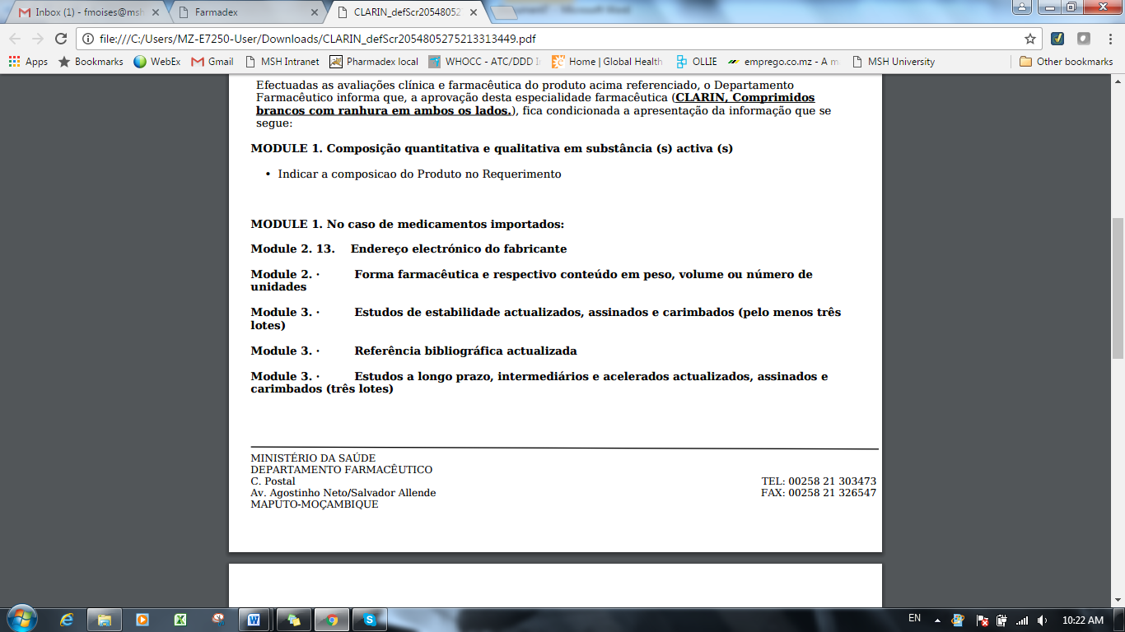

Comments from Screener below is the only required information

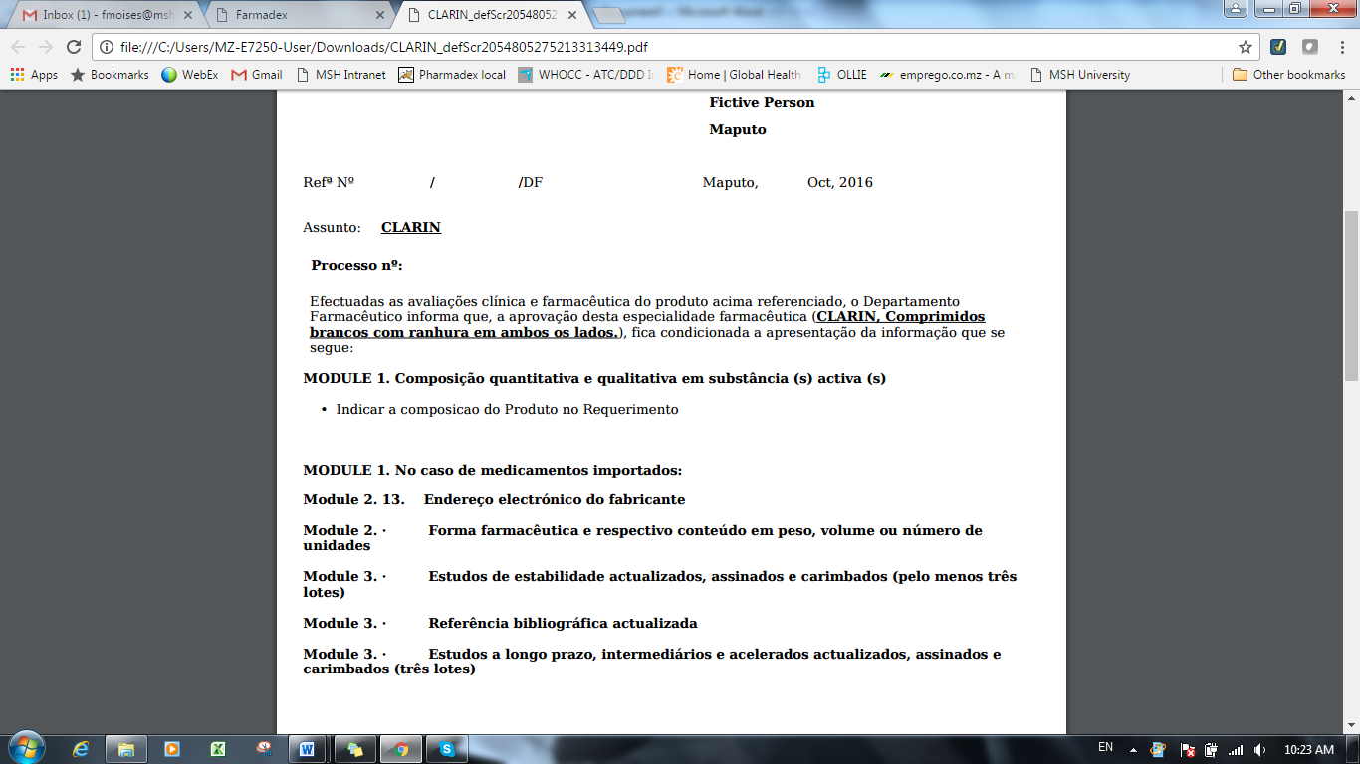

Who sign the letter is Head of PD (Dra Tânia Sitoie) >> please see below correct example:

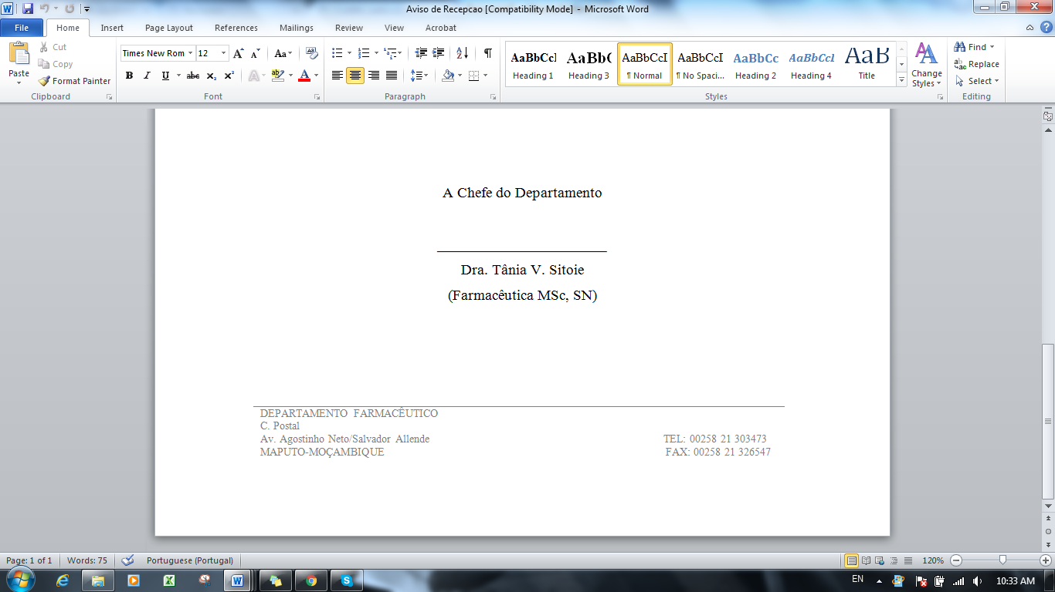

**REVIEW REPORT**

Please leave only Maputo remove **de**

